**ACMEGRADE CLOUDCOMPUTING PROJECT**

**CLOUD COMPUTING APRIL’23 PROJECT**

**GADI DIVYA SRI**

[**divyasrigadi07@gmail.com**](mailto:divyasrigadi07@gmail.com)

**7893797117**

**WHAT IS CLOUDCOMPUTING**

Cloud computing is a technology that utilizes remote servers on the internet, often referred to as "the cloud," to store, manage, and access data instead of relying on local storage devices. It allows users to store various types of data, including files, images, documents, audio, video, and more, in a centralized and online location. By leveraging the power of the internet, cloud computing provides convenient and scalable access to data from anywhere, at any time, using compatible devices.

In other way, Cloud computing is the practice of using remote servers over the internet to store, manage, and access data and applications, replacing the need for local storage and computing resources.

**PROBLEM STATEMENT:**

Create a resource group and Azure Synapse Analytics. Using the ASA instance create a pipeline and use copy data tool to move data from Azure blob storage Data Lake Gen2 to Azure SQL DW. Below activities need to be completed.

1) Creation of resource group, ASA, Storage account, Container, Dedicated SQL pool.

2) Creation of table in the dedicated SQL Pool.

3) Creation of pipeline to move data from Azure storage container to SQL pool using ASA.

4) The project deliverable will be screenshots of SQL Pool and resource groups being created.

**PROBLEM STATEMENT-1**:

Creation of resource group, ASA, Storage account, Container, Dedicated SQL pool.

* **Resource Group:** A resource group is a logical container in cloud computing that allows users to organize and manage related resources together, providing a unified approach to resource management within a cloud environment.

Steps to create a resource group:

1. Login to Azure Portal with your credentials using a specific subscription.

2. In the azure portal click on resource groups present in azure services.

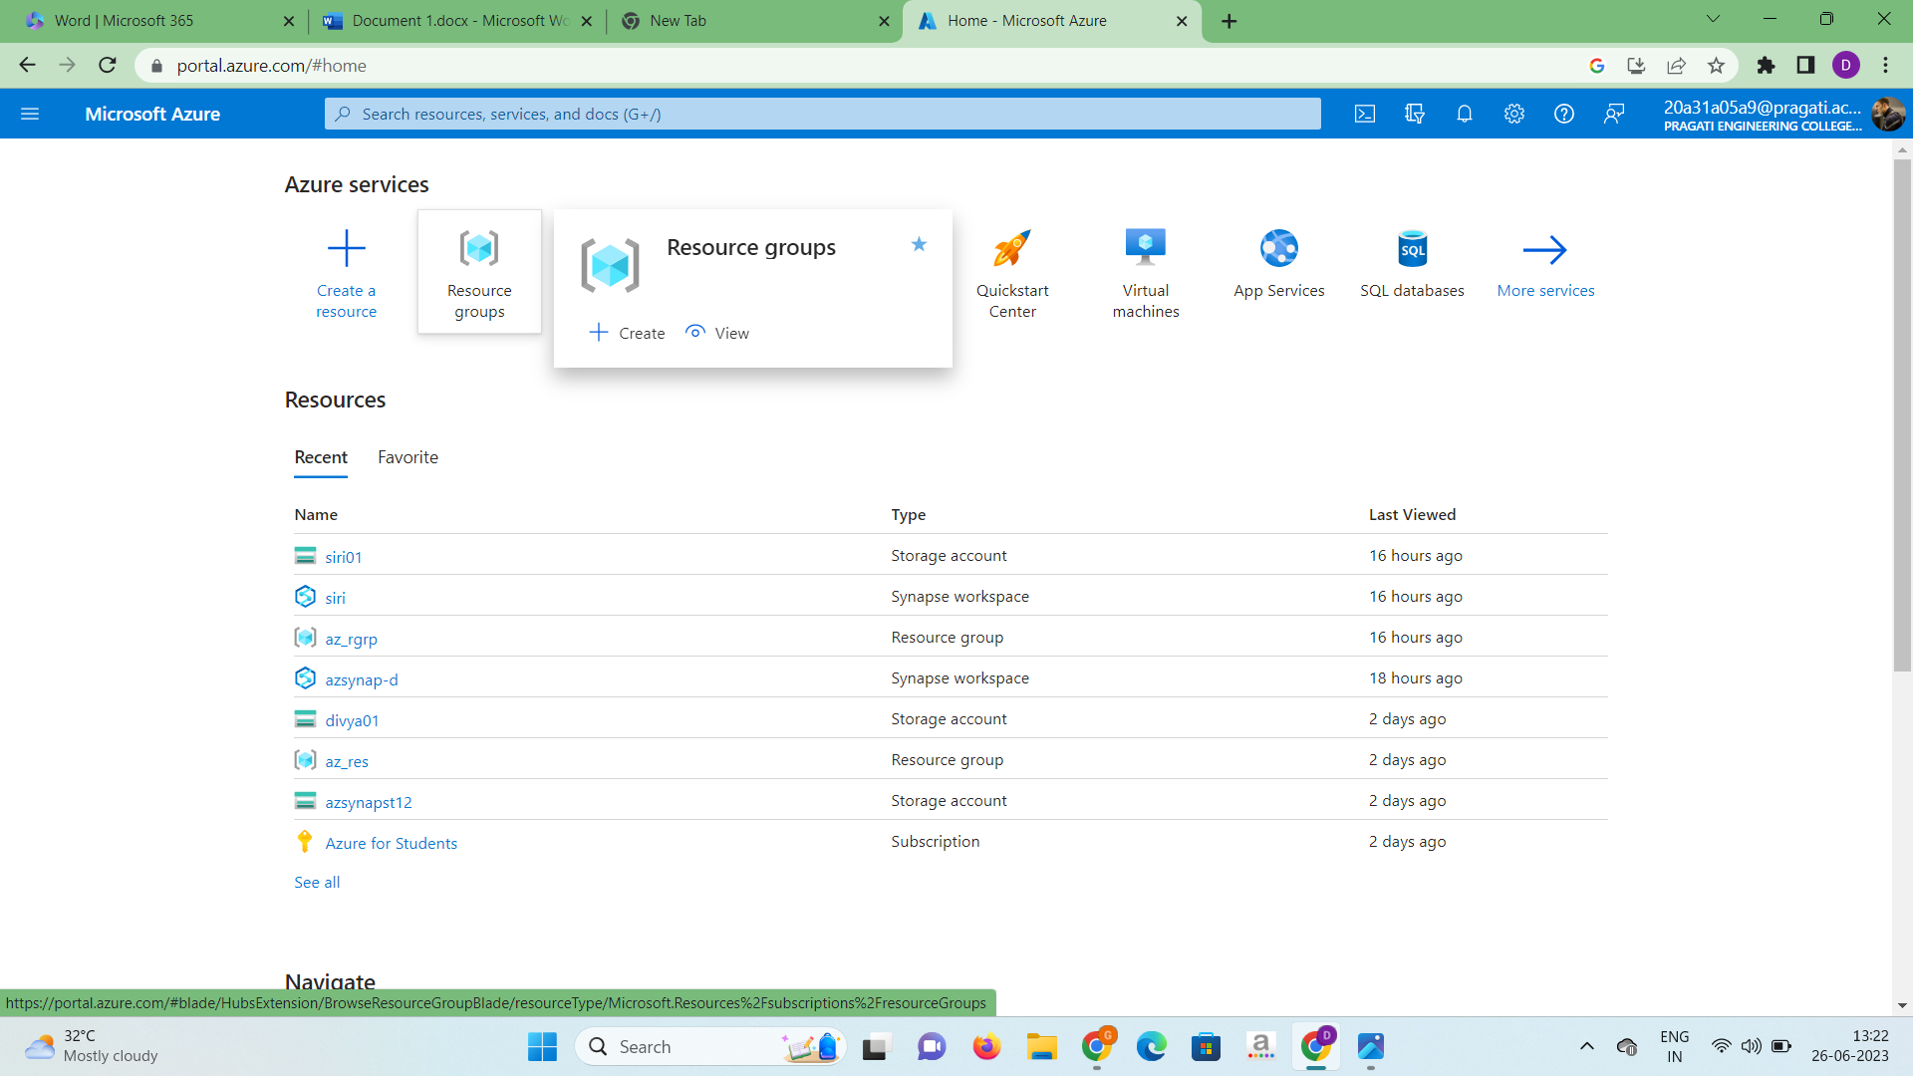

3.Click on create and name the name the group as “az_res” and select region as “Australia-east” and click on create.

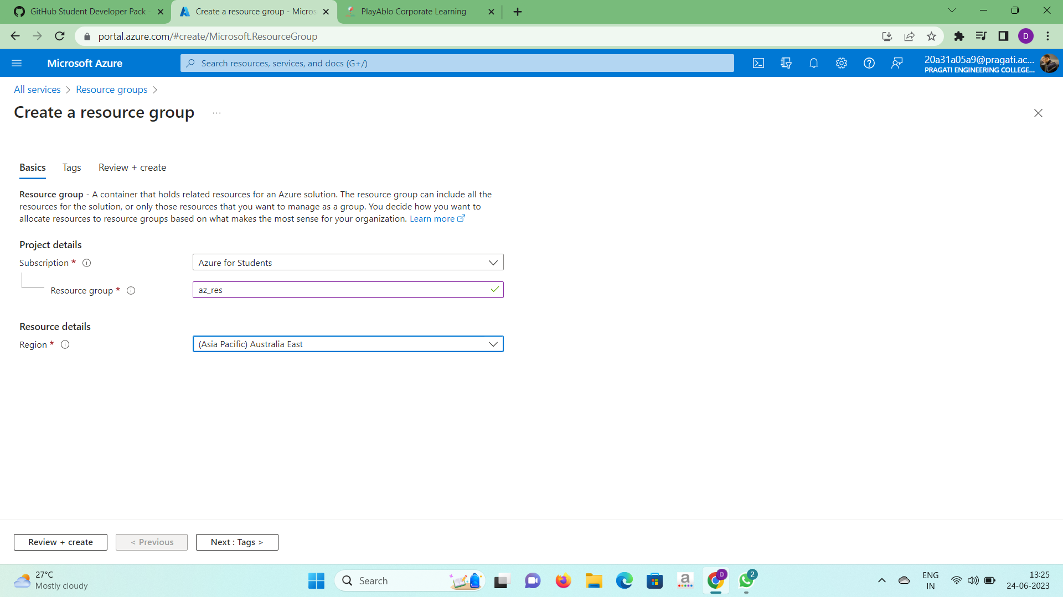

4. Click “Next”, then review your resource group and “Create”.

5. After validation process, you can see your new resource group created as

below.

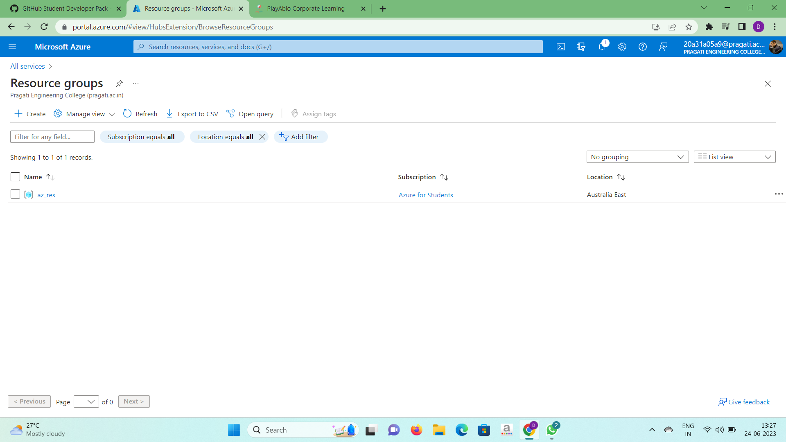

* **Storage account:** A storage account is a container that bands a set of Azure

Storage services together. Only data services from Azure Storage can be

comprised in a storage account. Integrating data services into a storage

account allows the user to manage them as a group.

Steps to create a storage account:

1.Click on storage account in the given azure services.

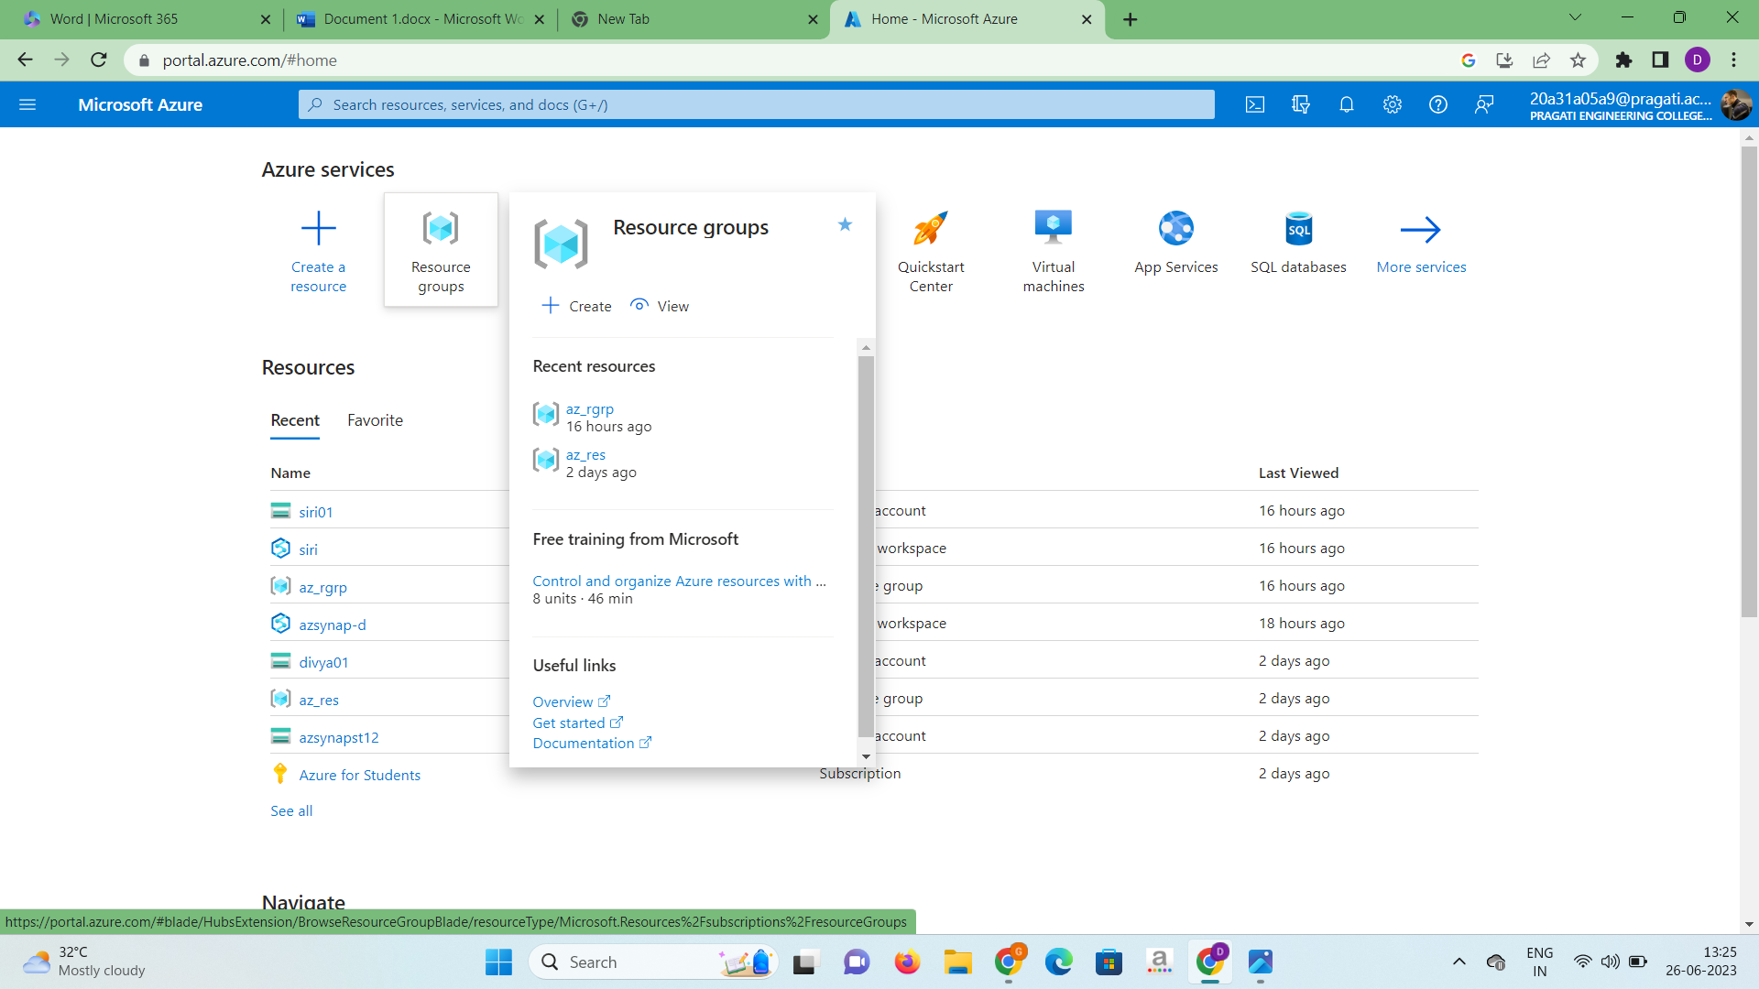

2.Click on create and name the storage account and select a region. In the

redundancy field select “locally redundant storage (LRS)”.

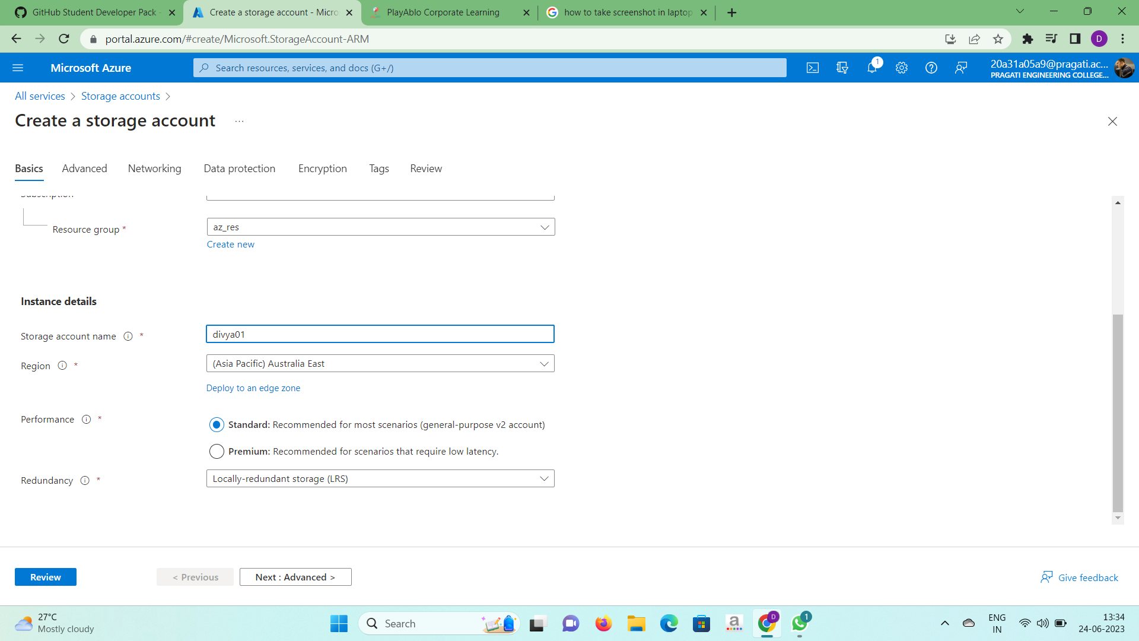

3.In the advanced field select enable hierarchical namespace option.

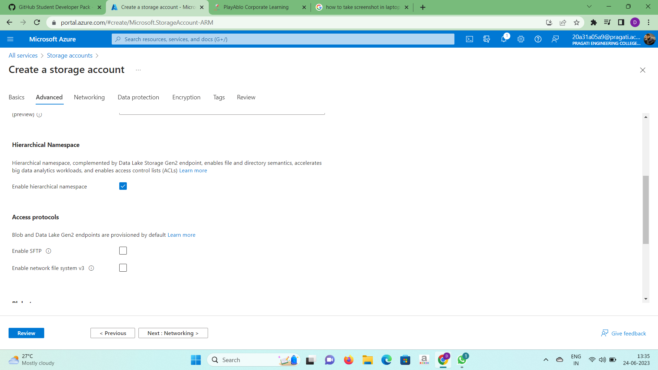

4.In the review field click on create and deployment will be completed and storage account will be created.

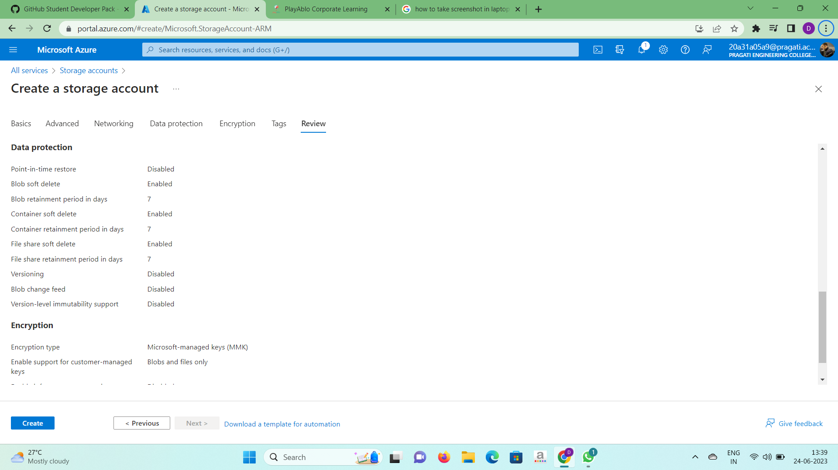

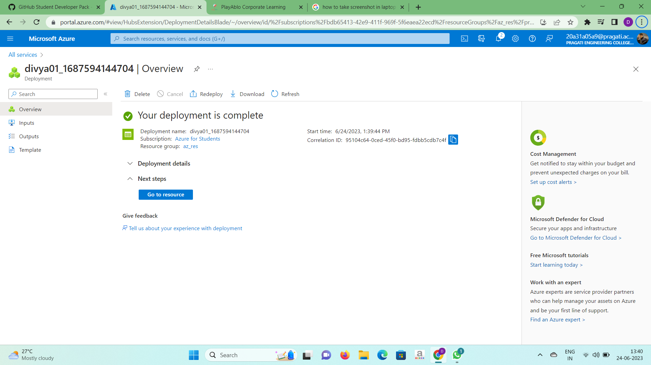

* **Containers:** A standard package of software is known as containers. Containers are lightweight, isolated environments that package applications and their dependencies, enabling consistent and portable execution across different computing environments.

Steps to create a container:

1.In storage account we have created click on containers option present in

Data storage section.

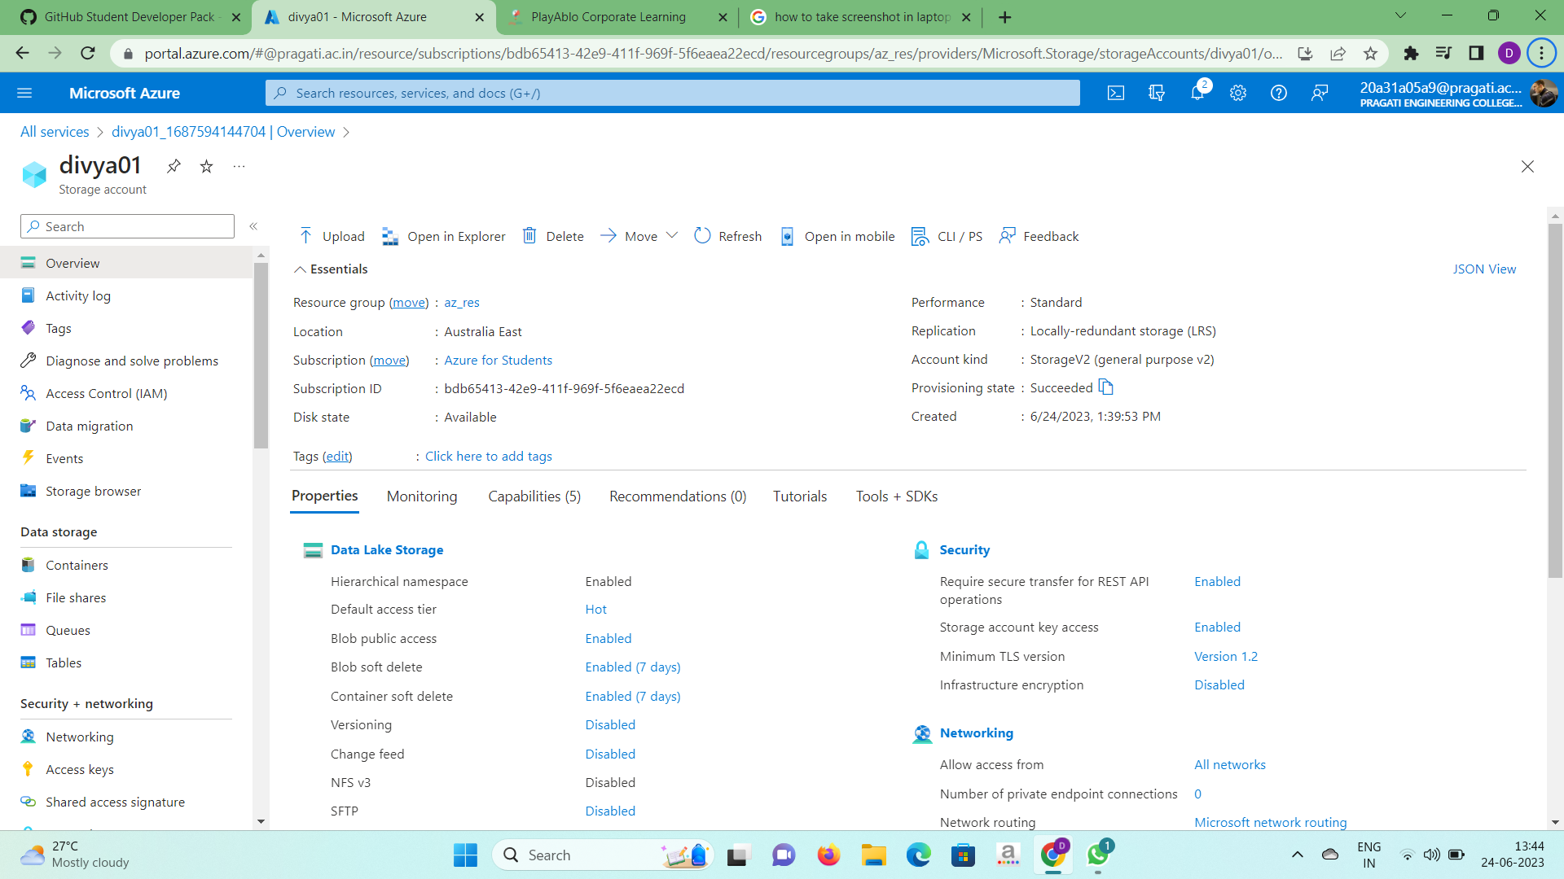

2.Click on the plus symbol(container) present in the upper tab. Name the new

container as “data” and click on create.

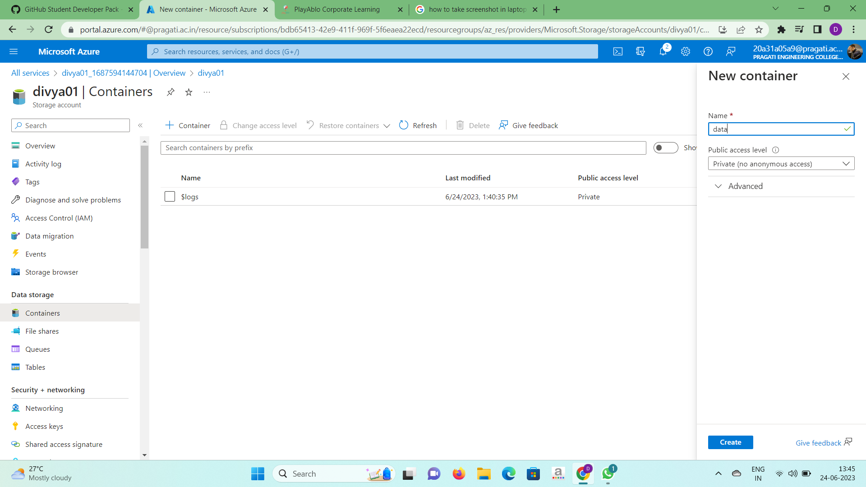

3.Now the container named “data” is created.

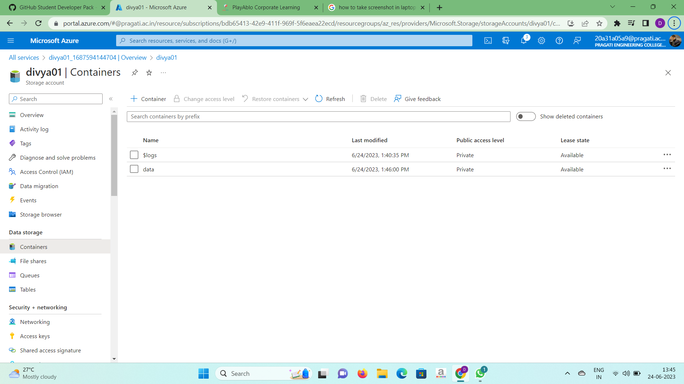

4.Now we need to create a directory in data. Open data container and click o

add directory option.

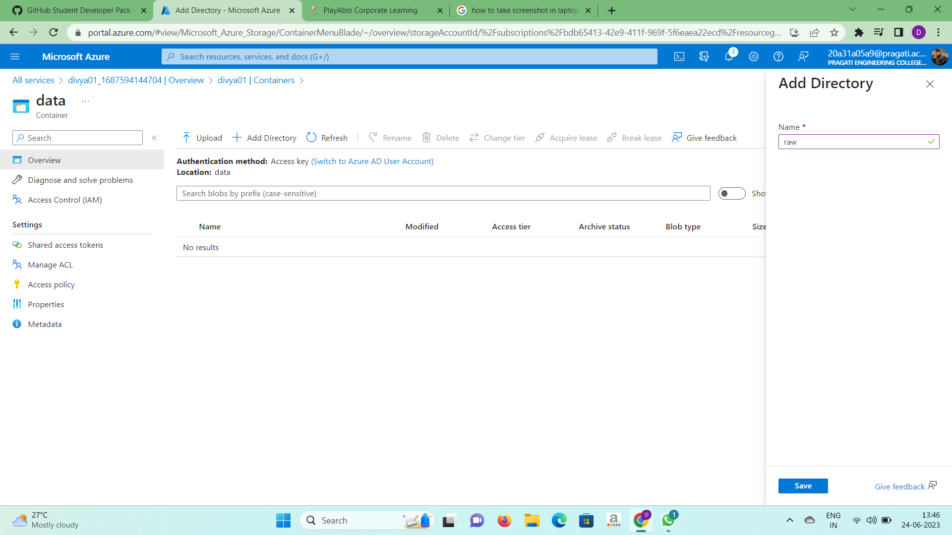

5.Here we created 2 directories namely “raw” and “parquet”.

 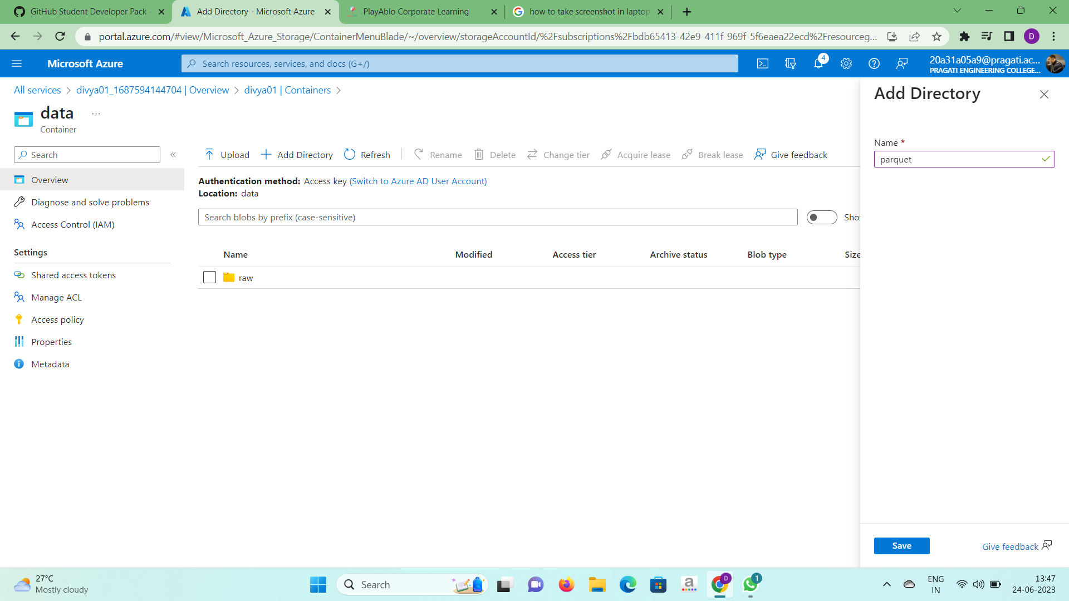

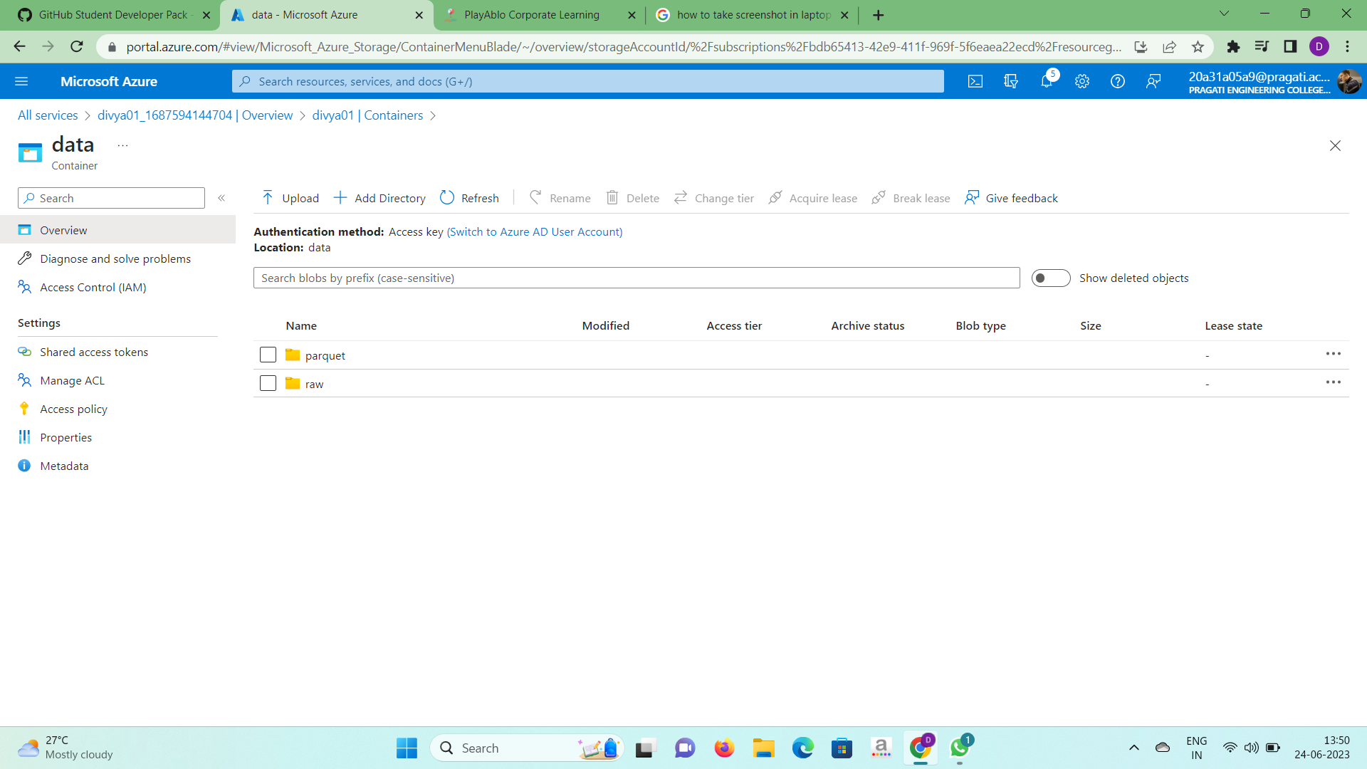

6.We need to upload files in both the directories. click on upload option for

the selected directory.

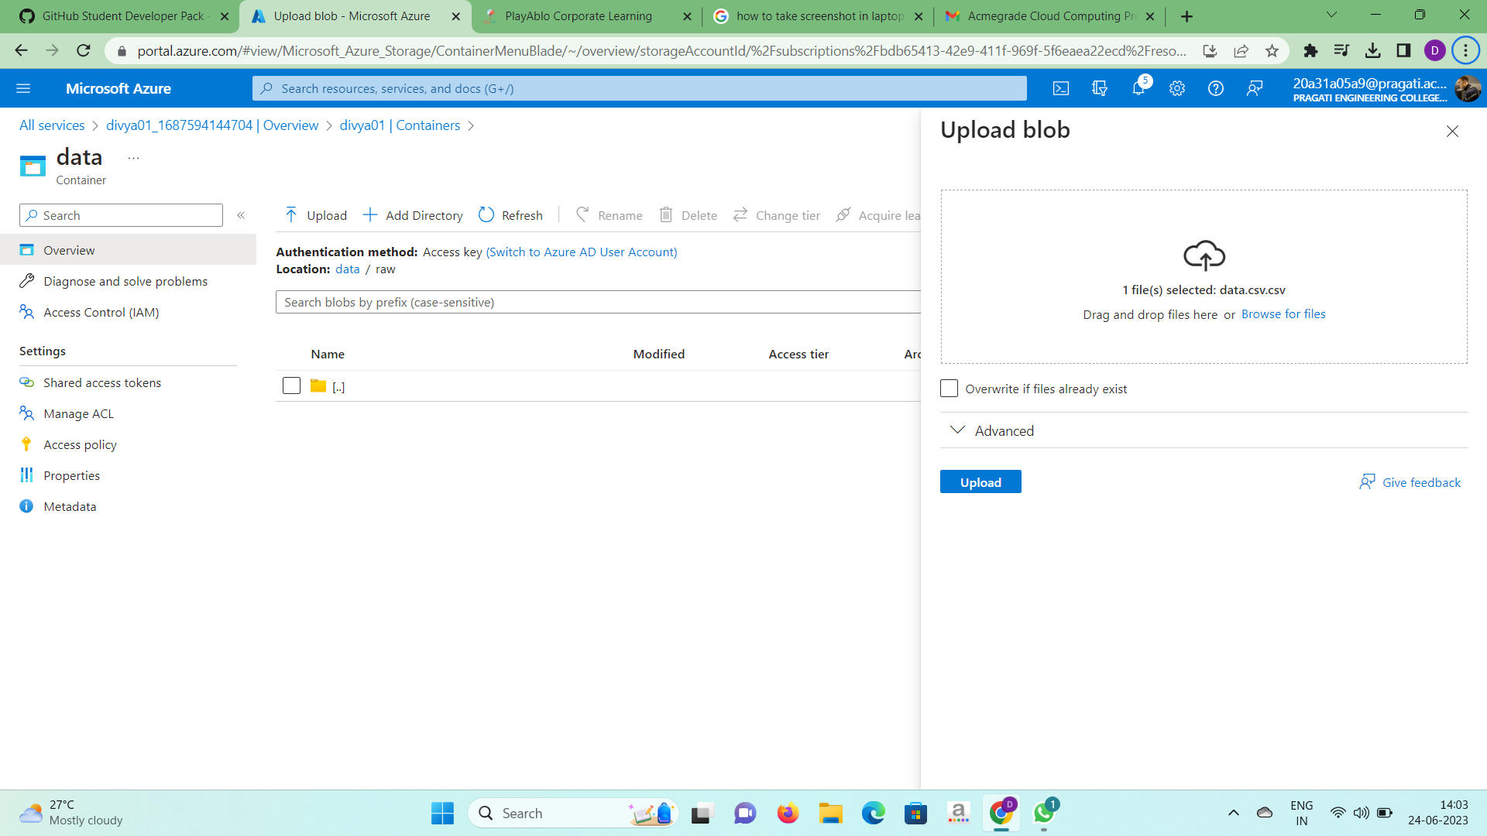

7.For the directory raw we have uploaded log.csv file and for the parquet

directory we have uploaded three files namely part-00000, part-00001 and

part-00002.

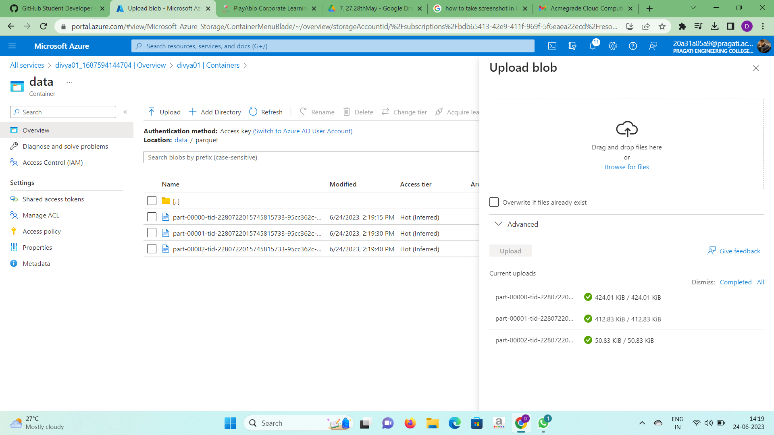

* **Azure Synapse Analytics (ASA):** Azure Synapse Analytics is an enterprise

analytics service that accelerates time to insight across data warehouses

big data systems. It brings together the best of SQL technologies used in

enterprise data warehousing, Apache Spark technologies for big data, and

Azure Data Explorer for log and time series analytics.

Steps to create an ASA:

1.Click on Azure Synapse Analytics present in Azure services and click on create option.

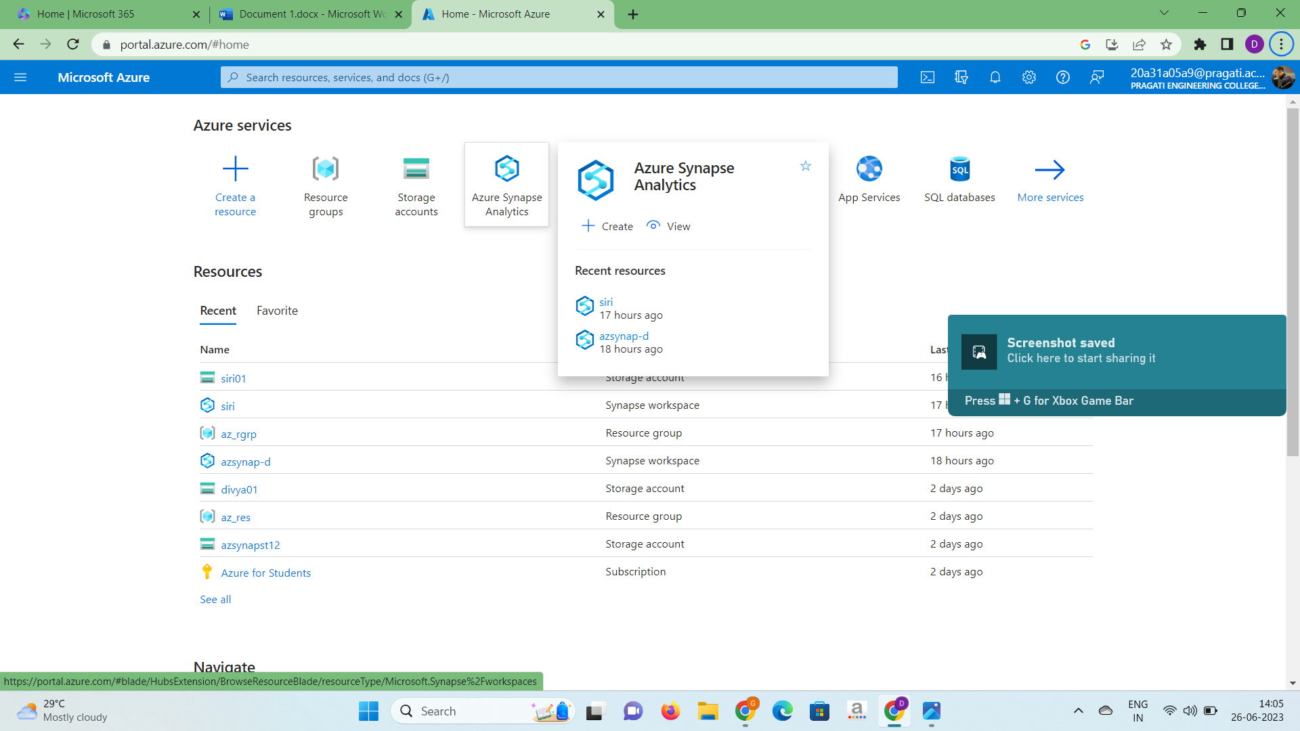

2.Now we need to fill the columns in project details and workspace details sections.

* In project details section select the resource group name you have

created before.

* In workspace details section select the workspace name i.e storage

account name.

* Create new account name and file system name using create new

option which is present below those columns.

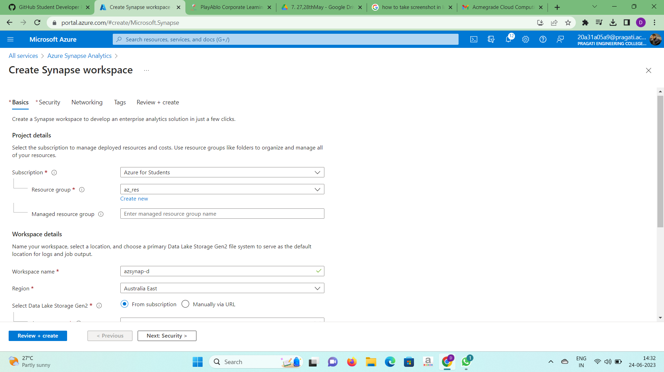

3.Go to security section and create a password while the username is sqluseradmin.

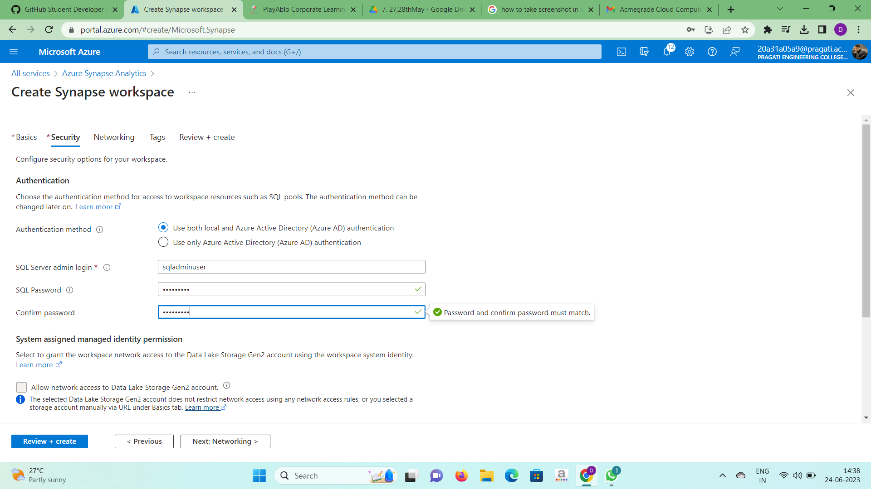

4.Goto review+create section and click on create and then deployment will

be completed after sometime and ASA is created.

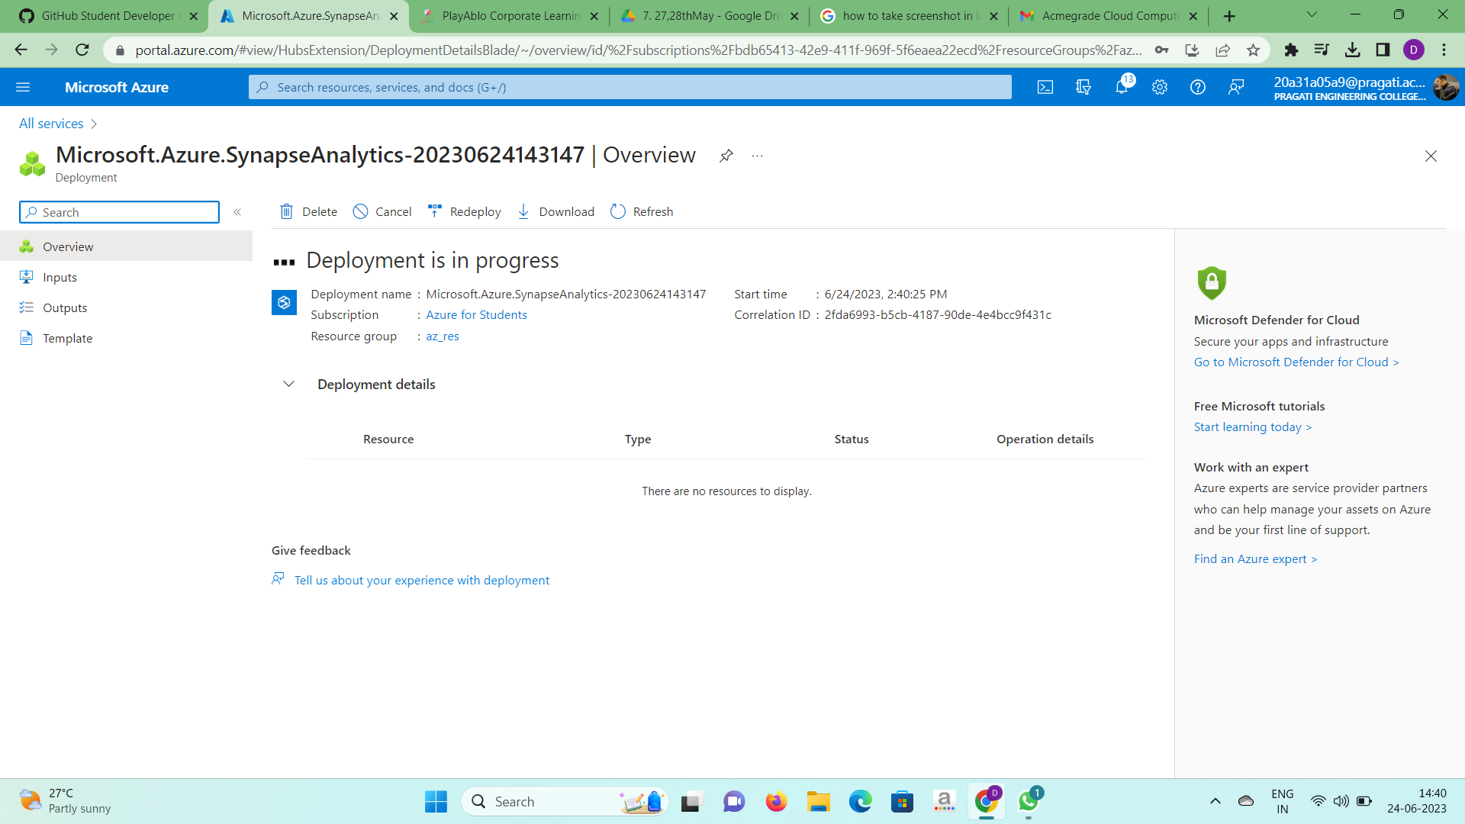

* **Dedicated SQL Pool**: Dedicated SQL pool (formerly SQL DW) refers to the

enterprise data warehousing features that are available in Azure Synapse

Analytics.

Steps to create dedicated sql pool:

1.In the ASA account we created click on open synapse studio.

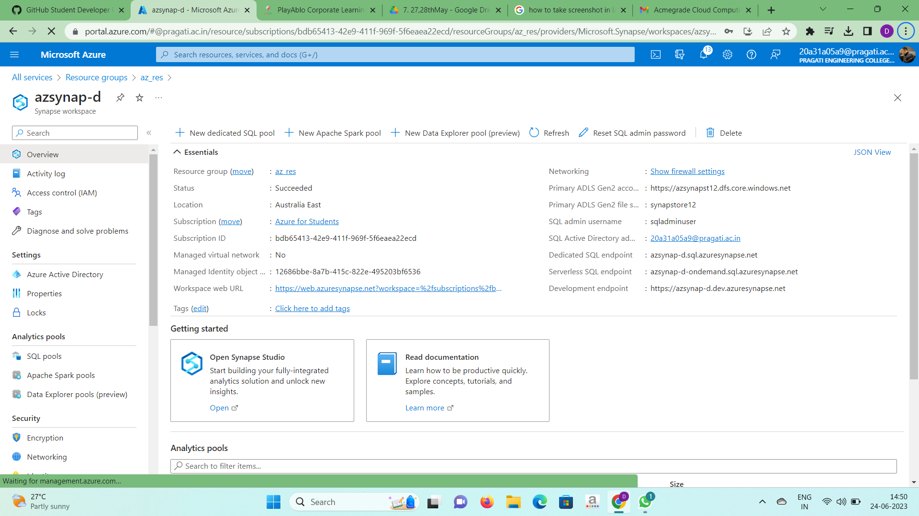

2.Another window will open as shown below and click on data option in the

left corner.

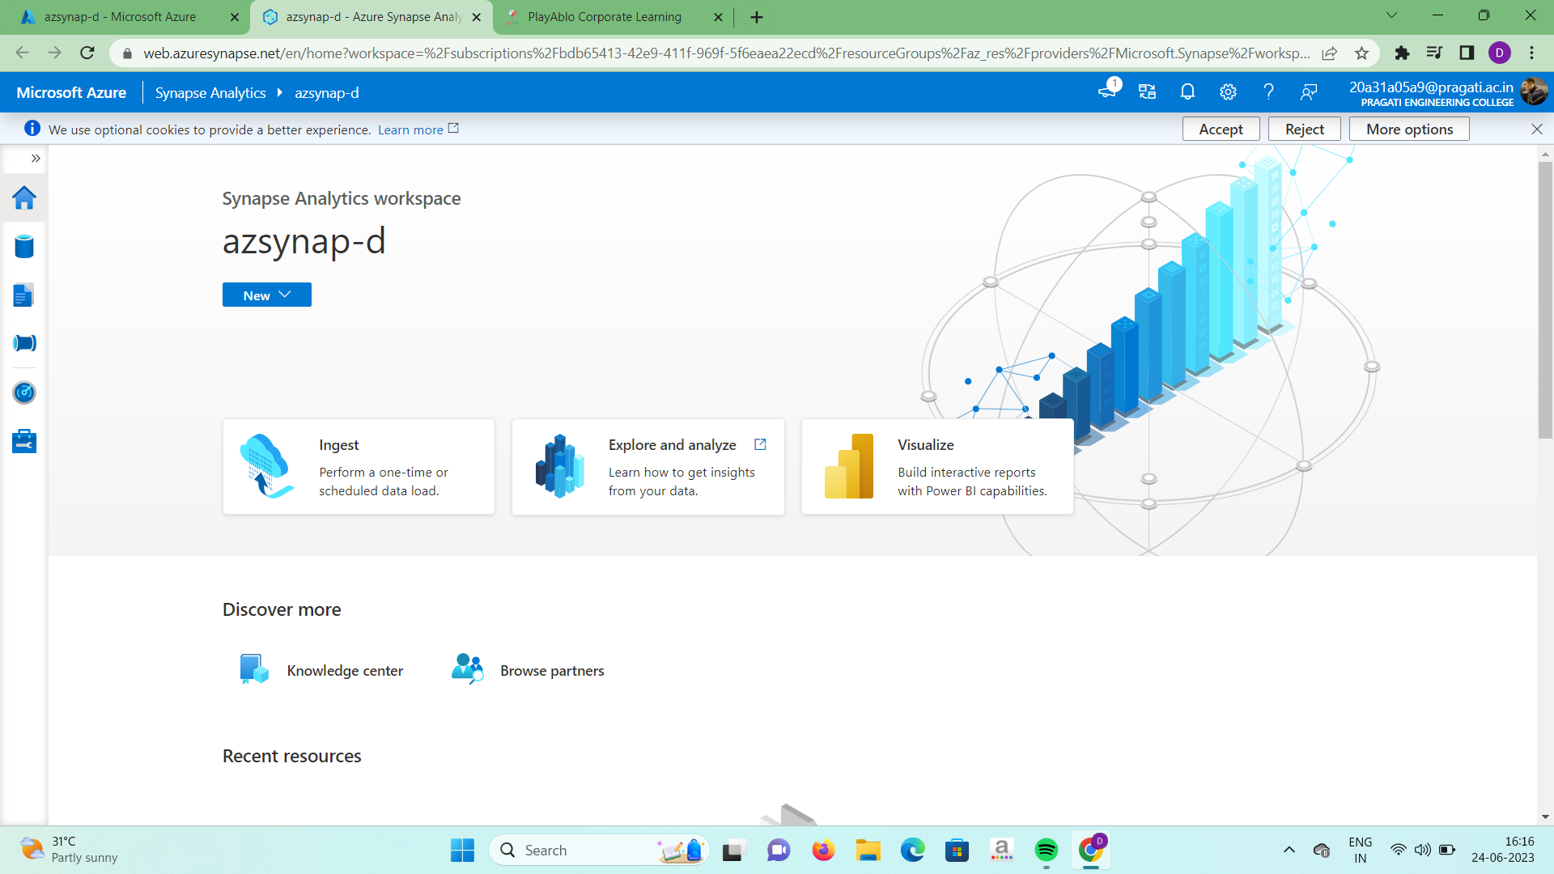

3.At your storage account goto sql pools and click on new dedicated sql pool.



4.Name the dedicated sql pool and decrease the performance level to

minimum. Goto on review+create and click on create option.

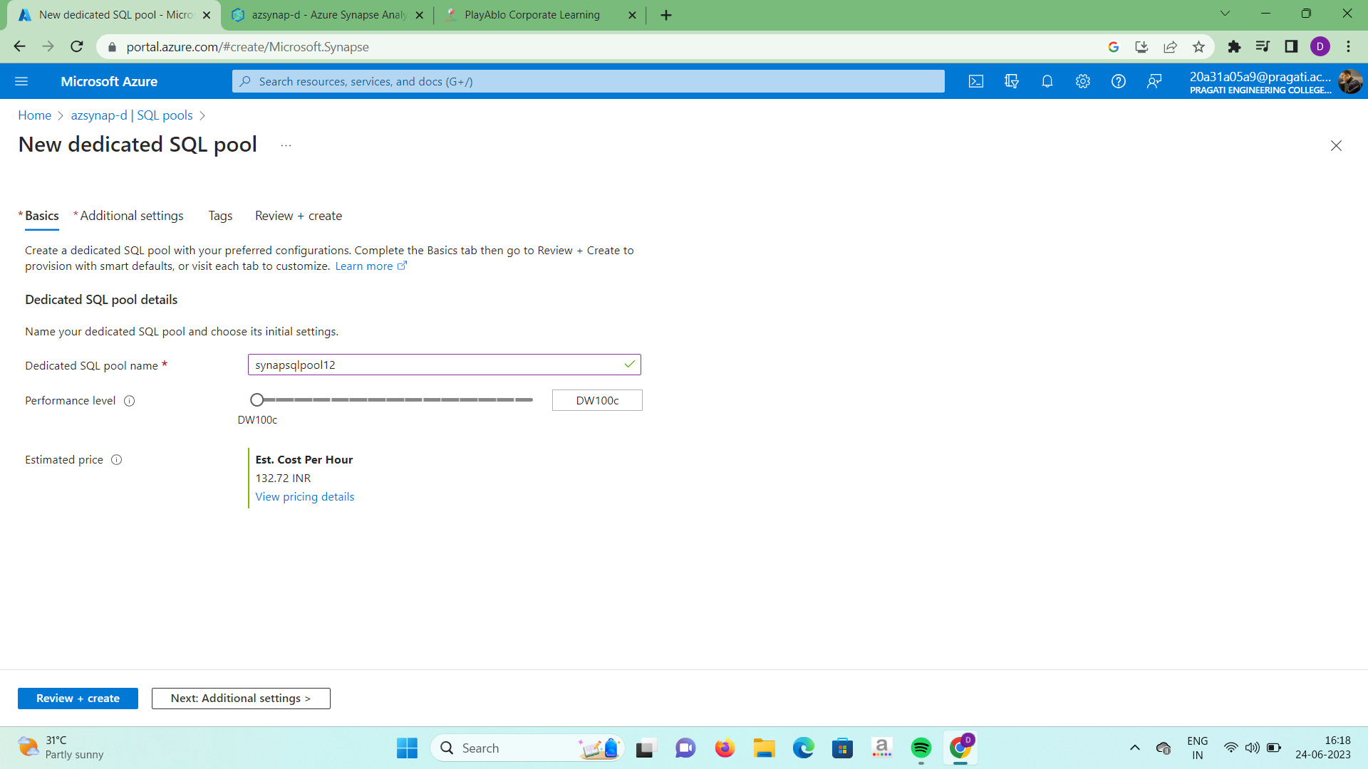

5.After deployment our dedicated sql pool will be created.

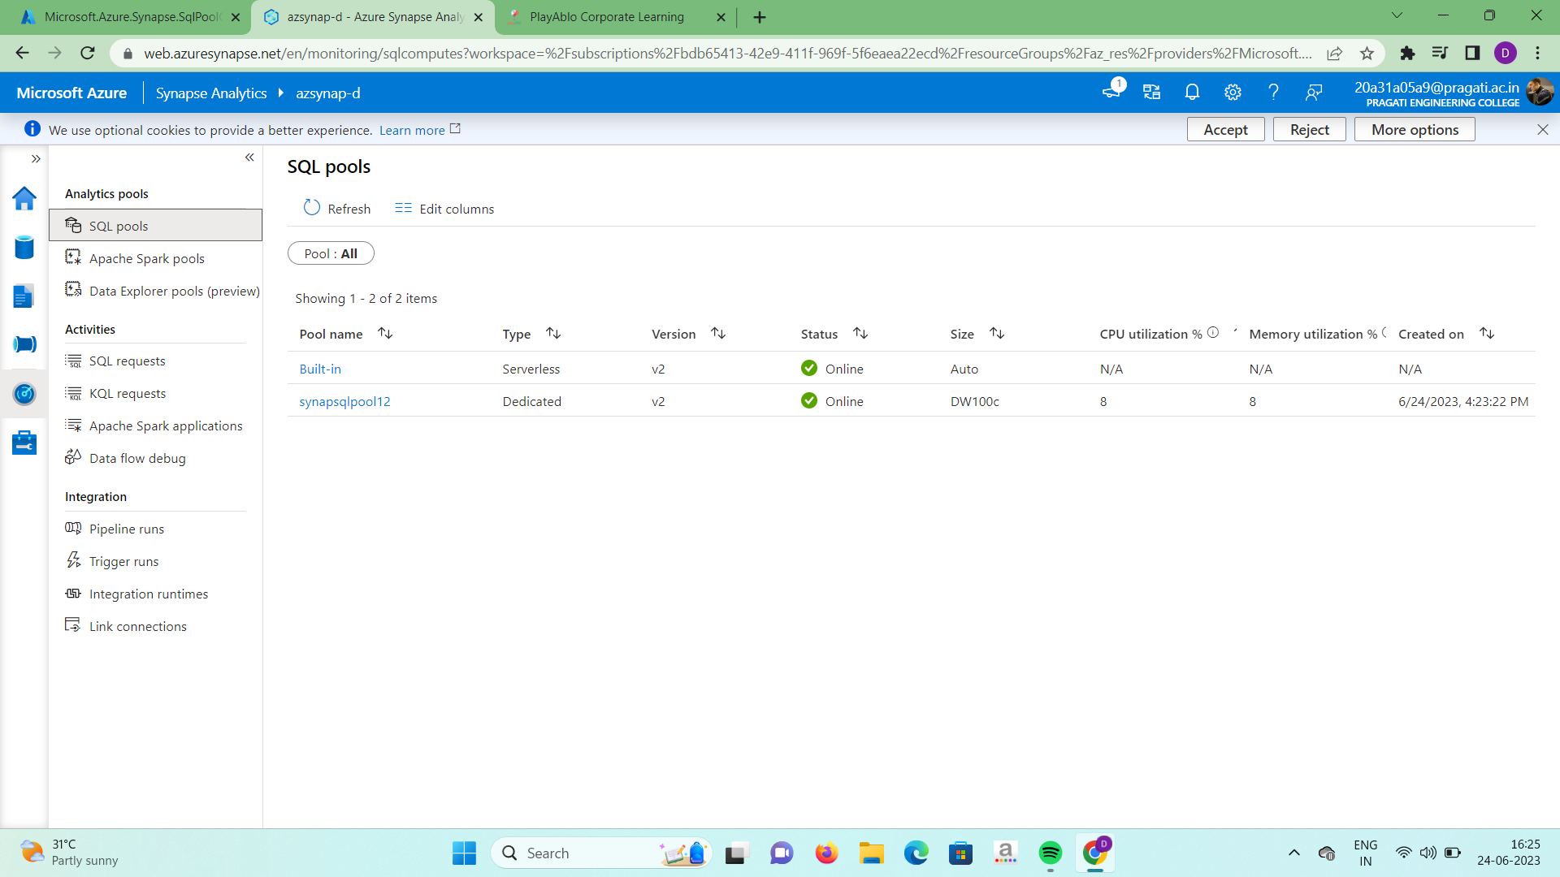

**PROBLEM STATEMENT-2:**

Creation of table in the dedicated SQL Pool.

Steps for the creation of table:

1.In the Azure Synapse Analytics workspace click on new and select SQL script.

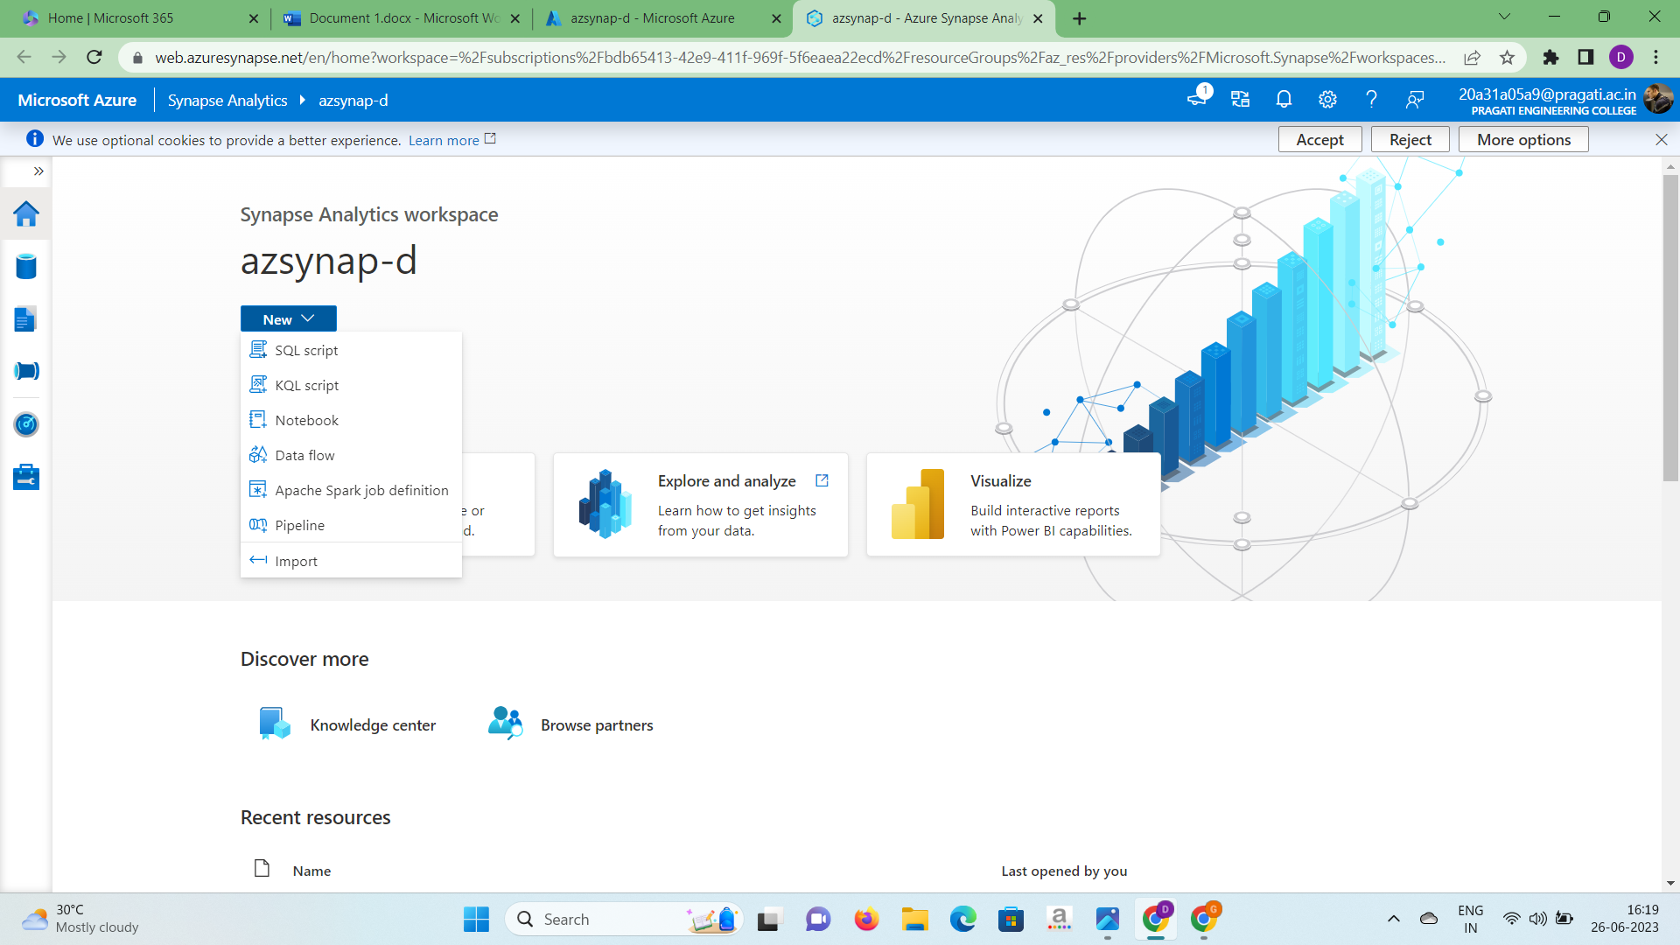

2.In the properties section, name the sql script as “etl_process” and in the connect field to dedicated sql pool you have created.

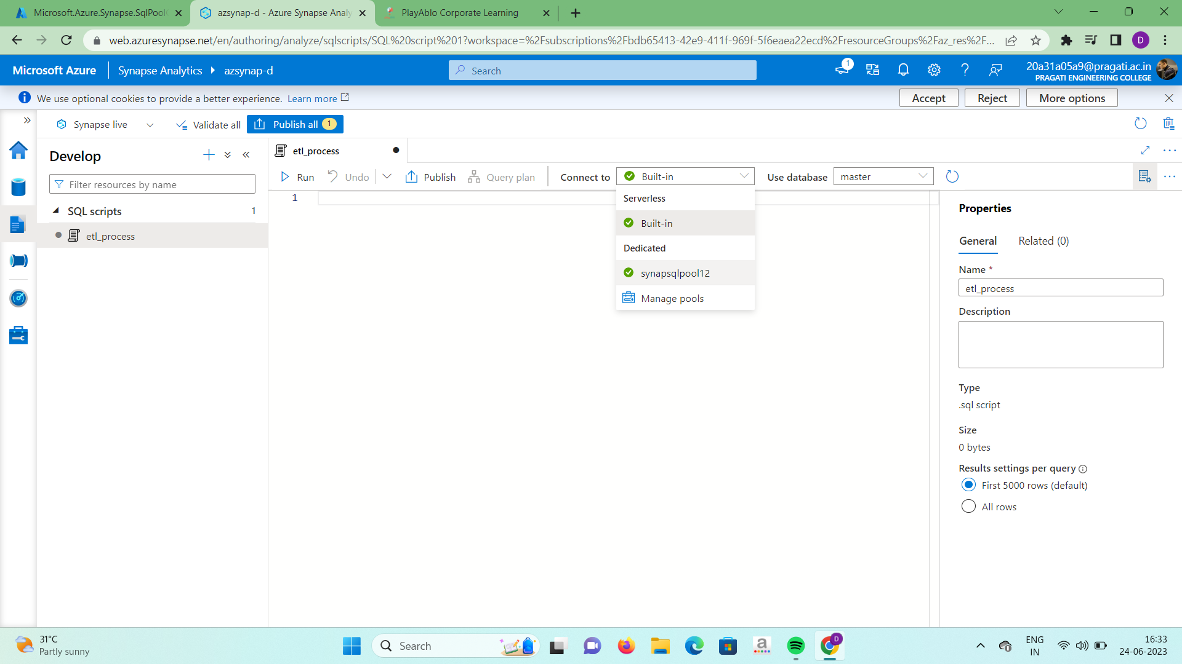

3.Now we need to create a master key for this database using sql commands. You

need to give your own password and run the sql command.

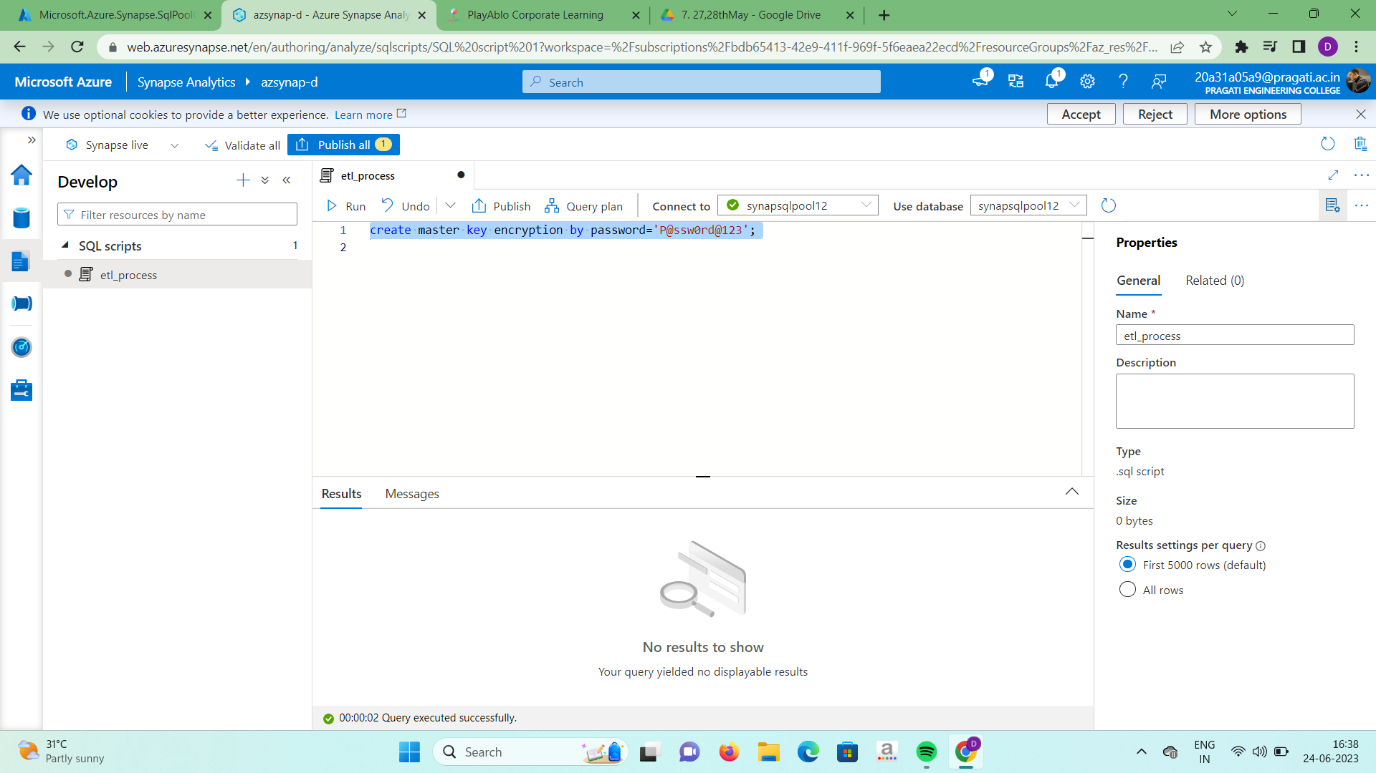

4.After creating master key we need to make a connection to the storage account.

* In the sql command identity is your storage account name
* For the secret field go to your account and in that click on access keys option where you will get the key column copy that and paste it in the sql command.
* Run that sql command.

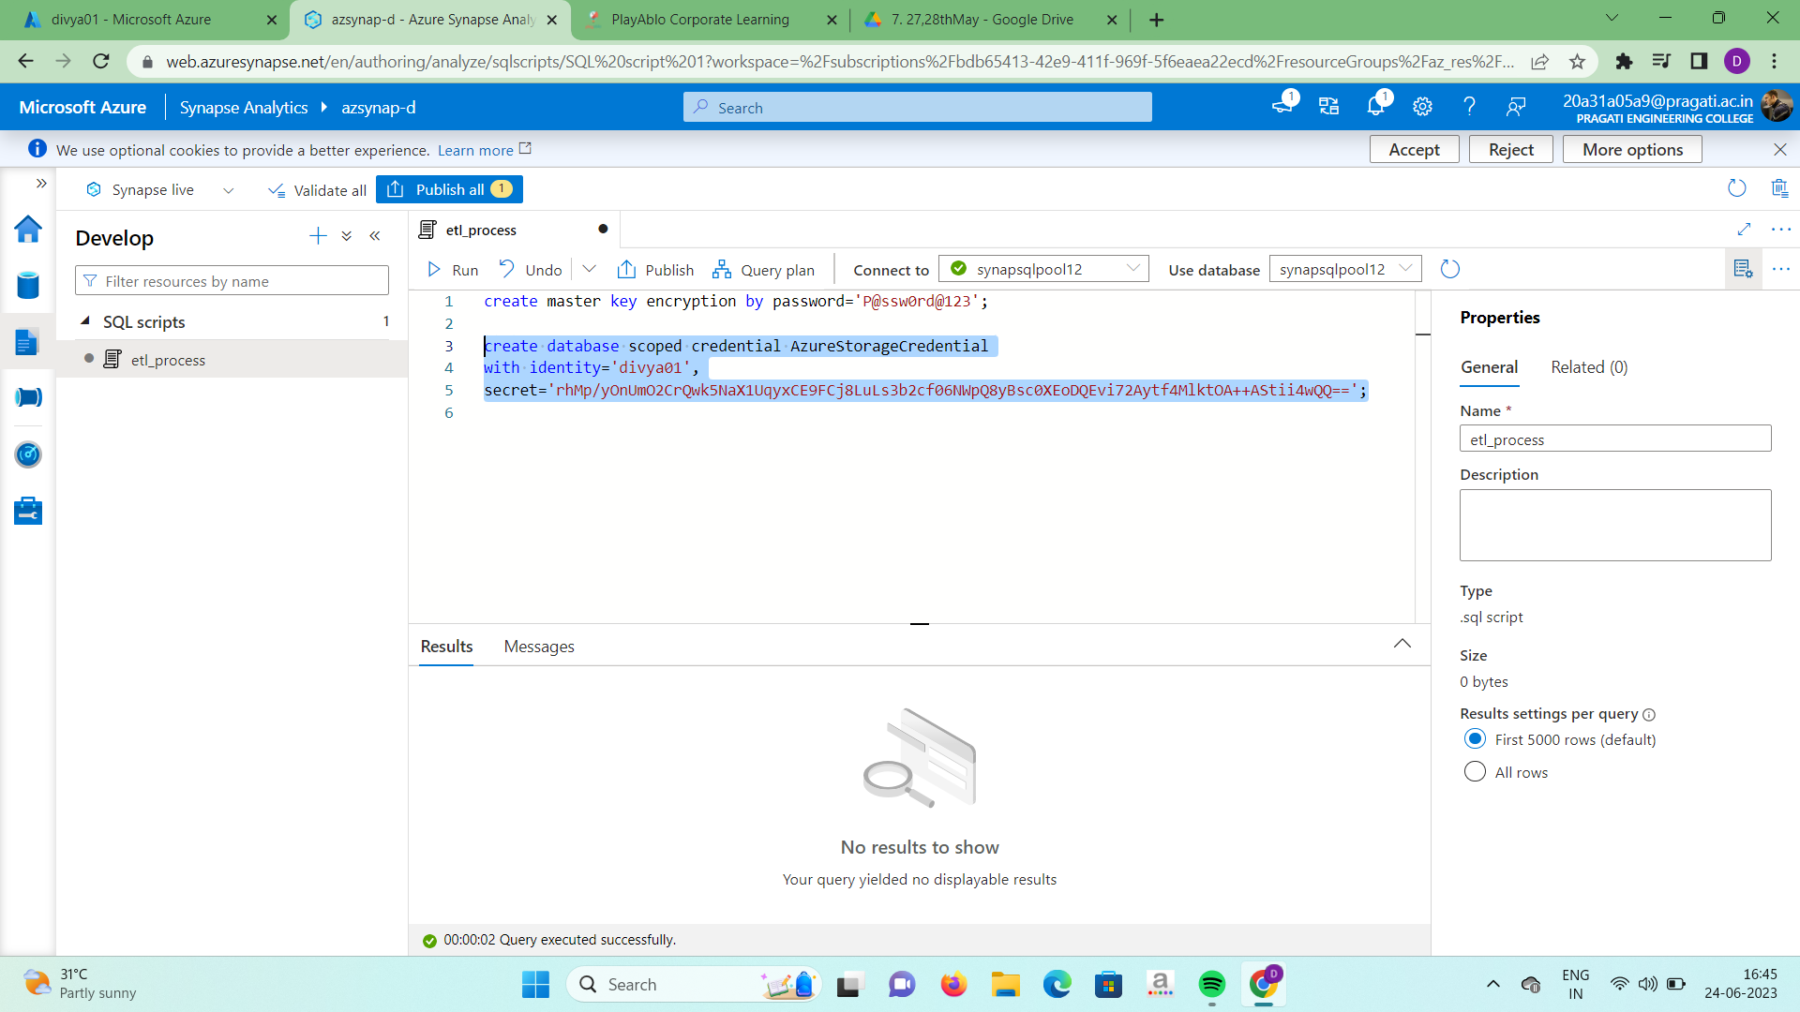

5.In this step we need to make a connection to the data folder using the shown sql command.

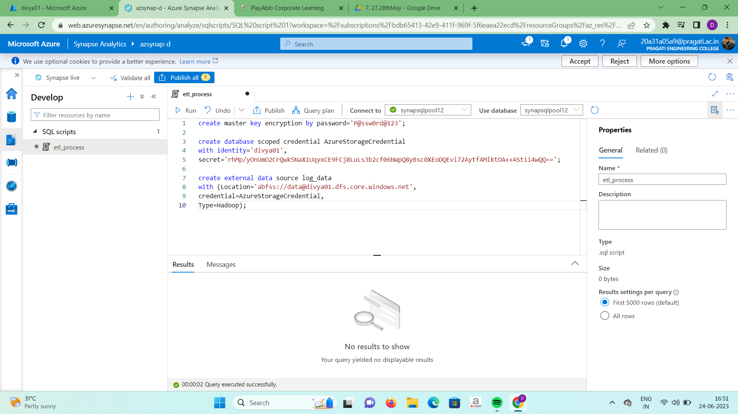

6.Now we will be creating a external file format. In that sql command we need to

specify the format type and data compression technique.

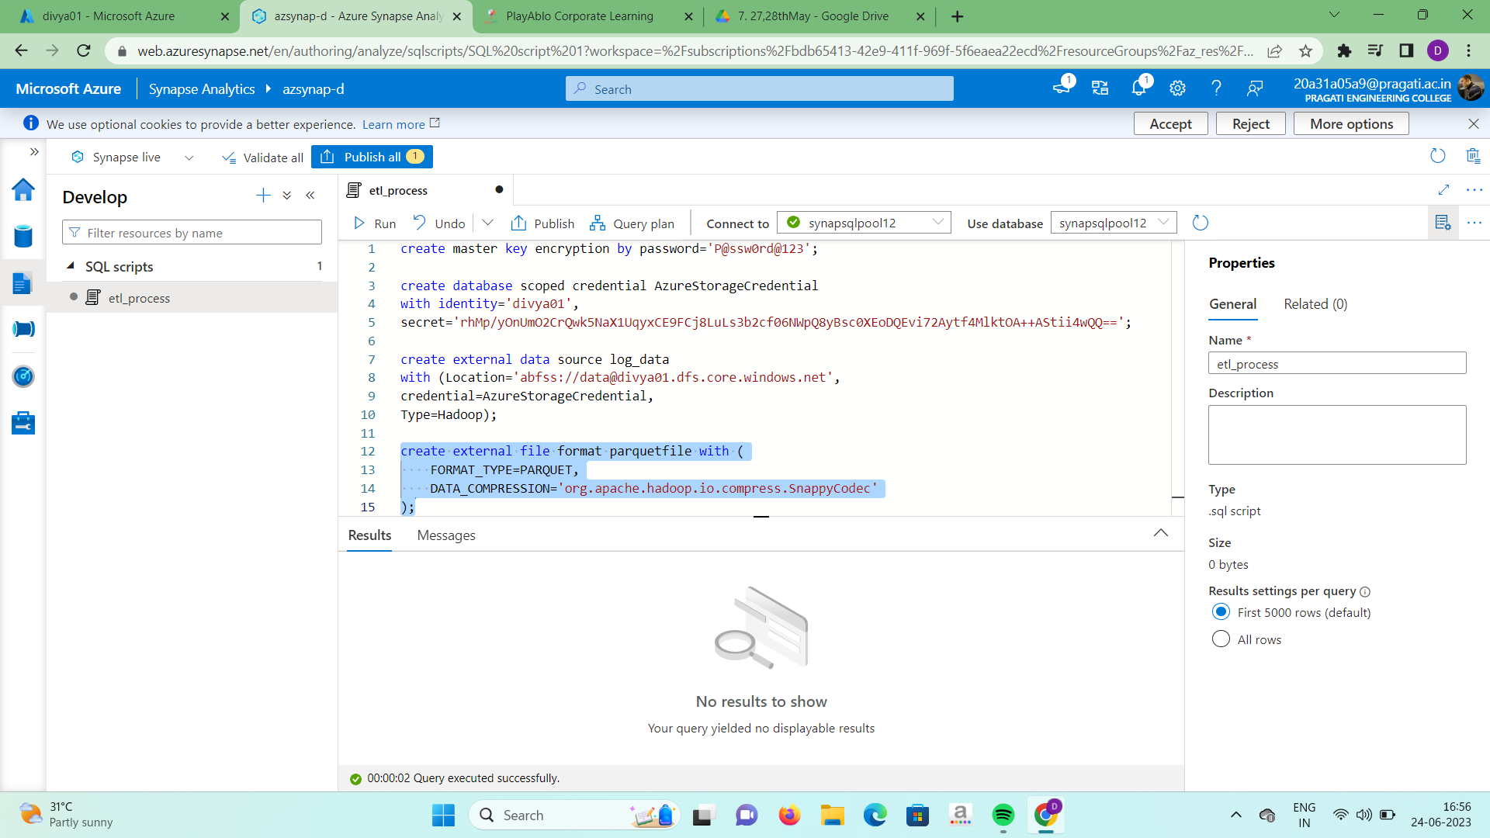

7.Now create a table for the data. Specify the column names and their datatypes in the sql command and run the command.

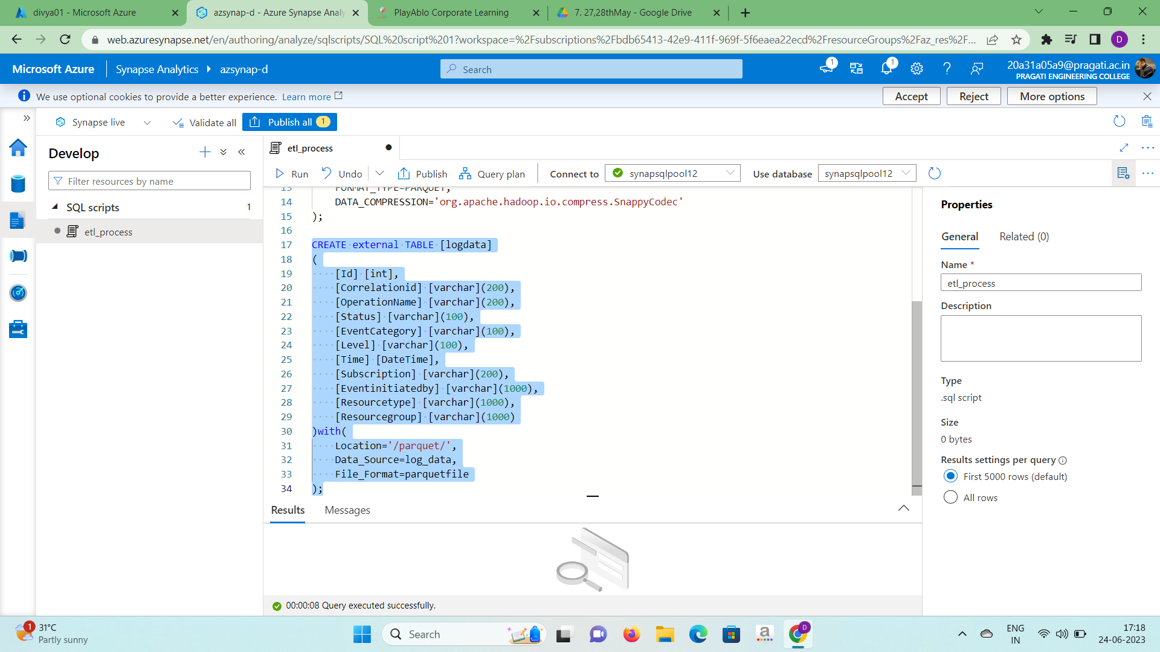

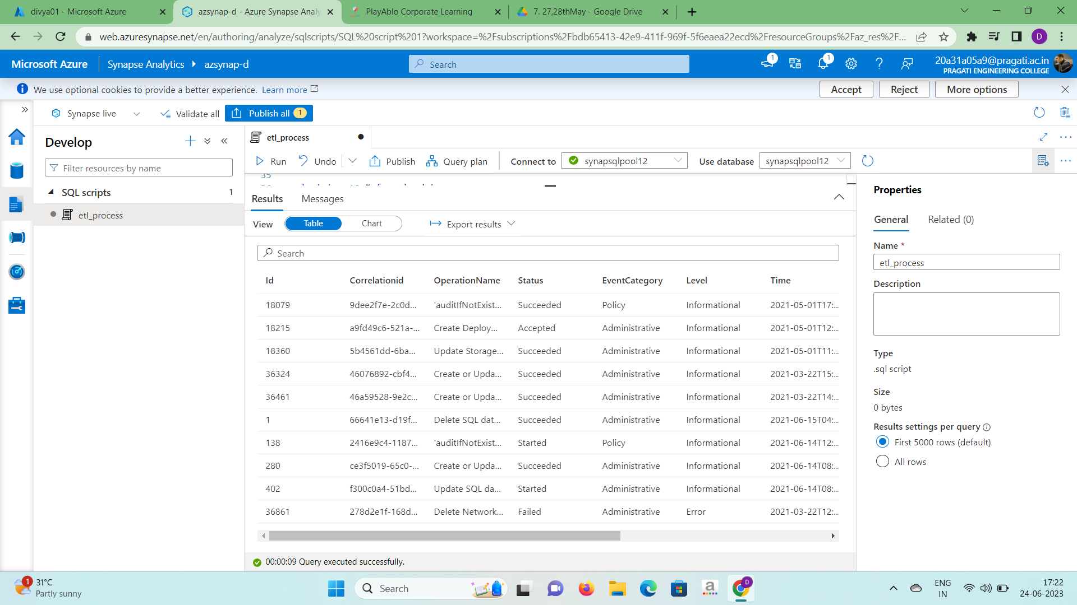

8.The table has been created. In order to save the sql script click on publish all

option at the top and click on publish.

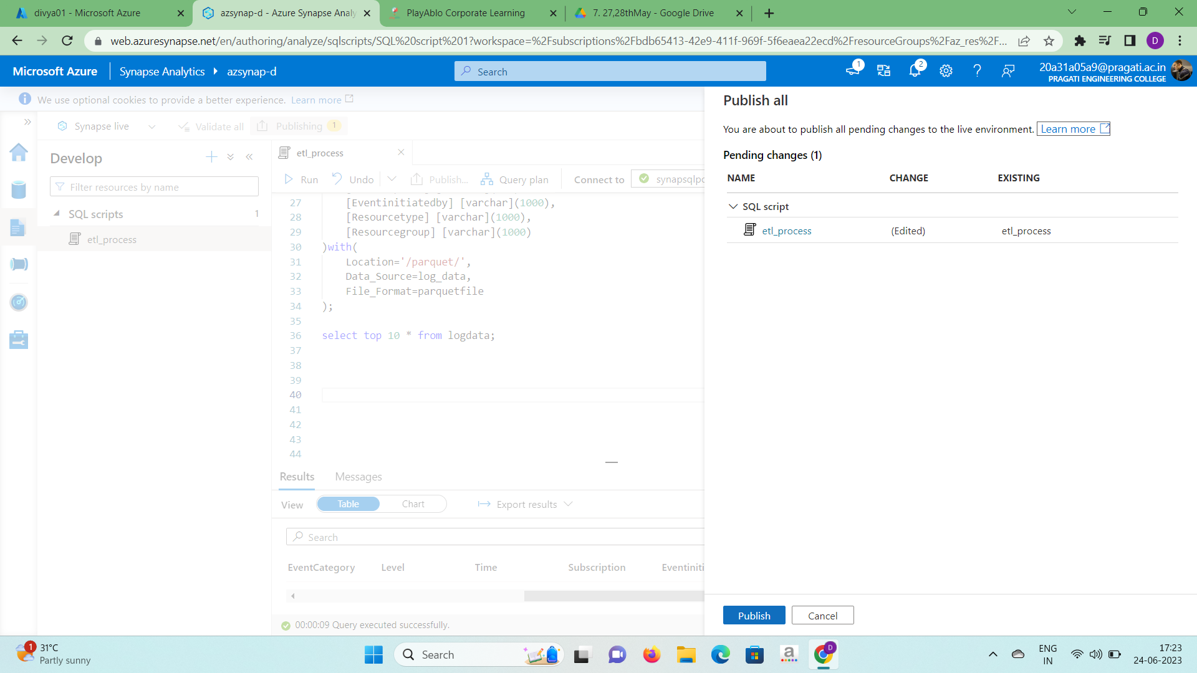

**PROBLEM STATEMENT-3:**

Creation of pipeline to move data from Azure storage container to SQL pool using ASA.

Steps to create a pipeline:

1.In the azure synapse analytics work space click on Ingest and then click on built-in copy task.

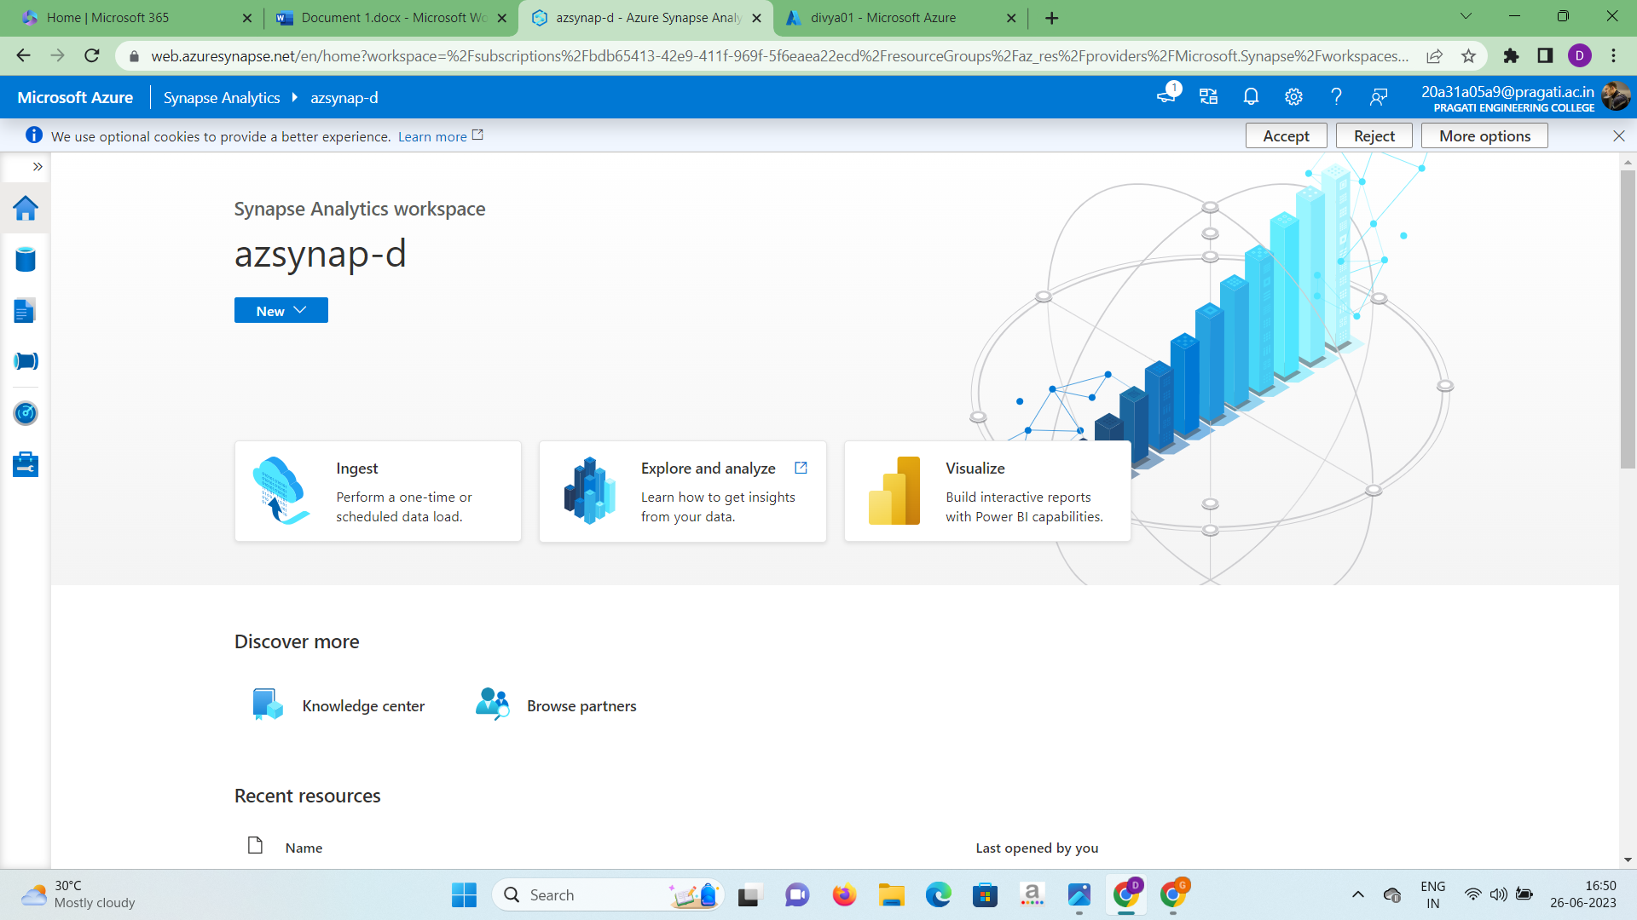

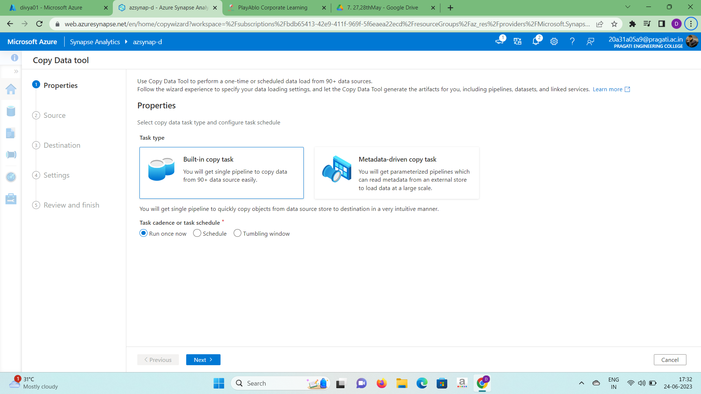

2.Select the source type as “Azure Blob storage” and click on new connection.

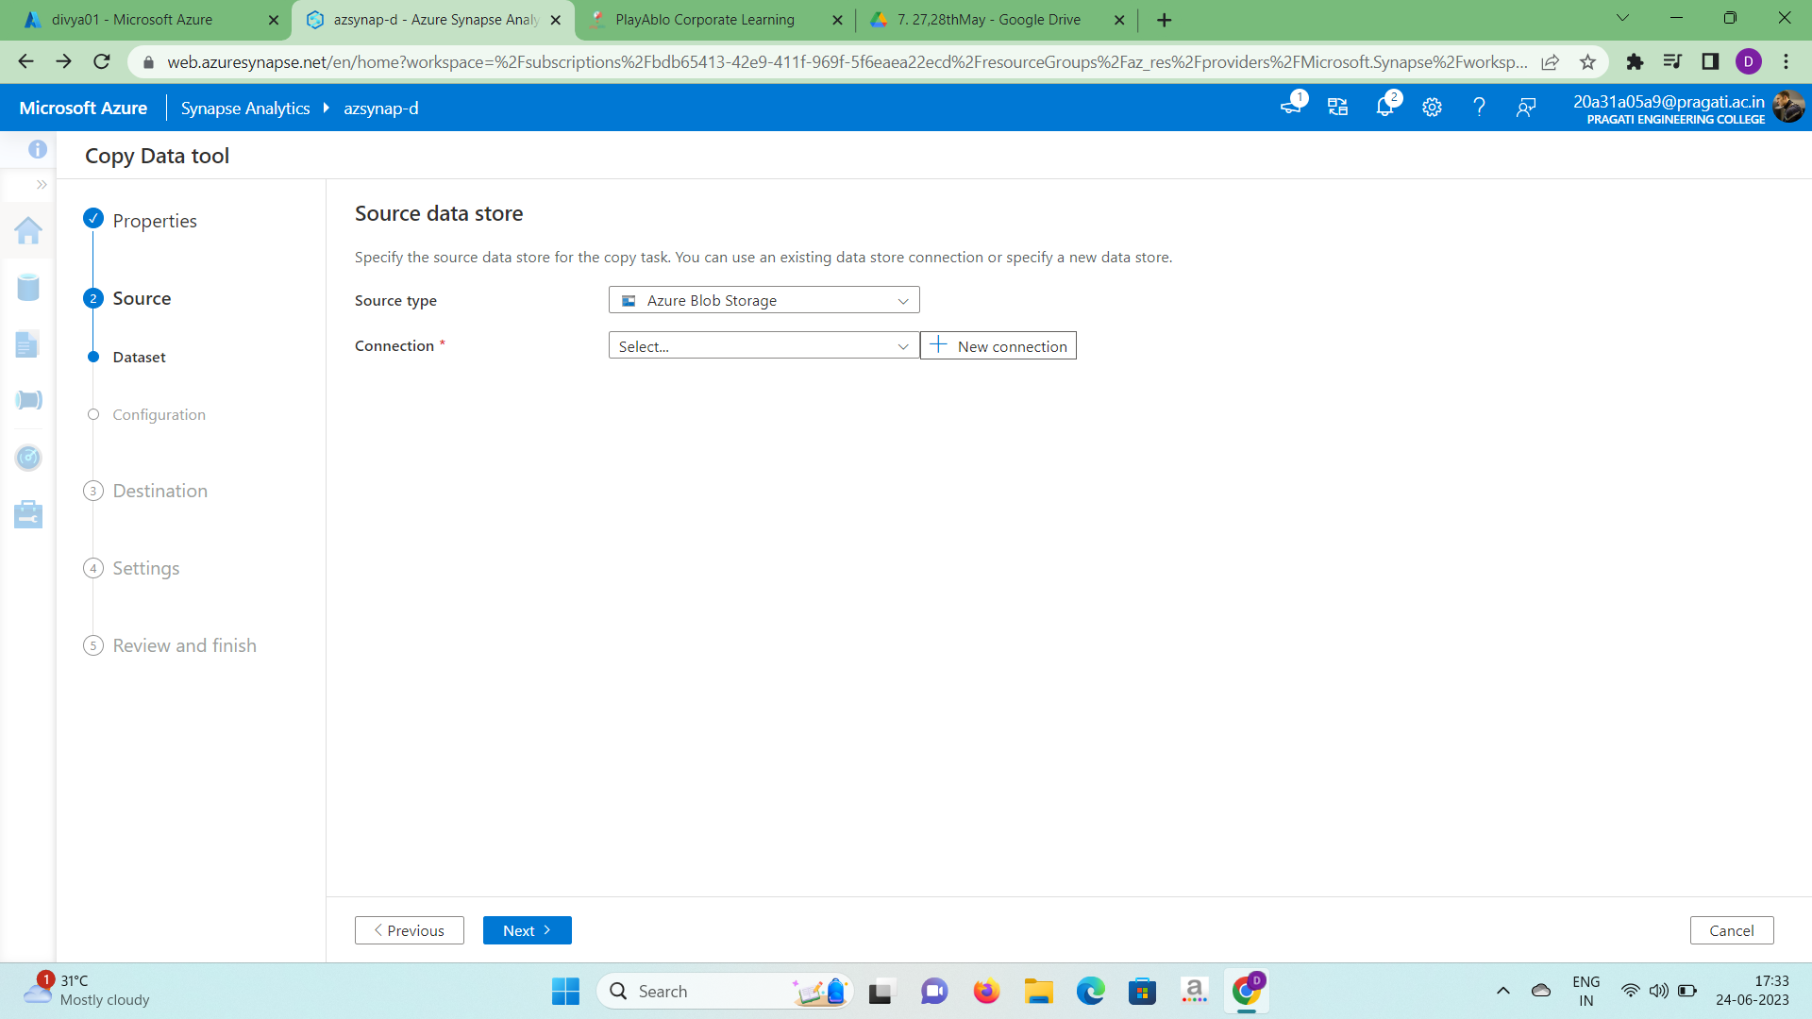

3.Select your azure subscription and enter your storage account name and test the connection. If the connection is successfully click on create.

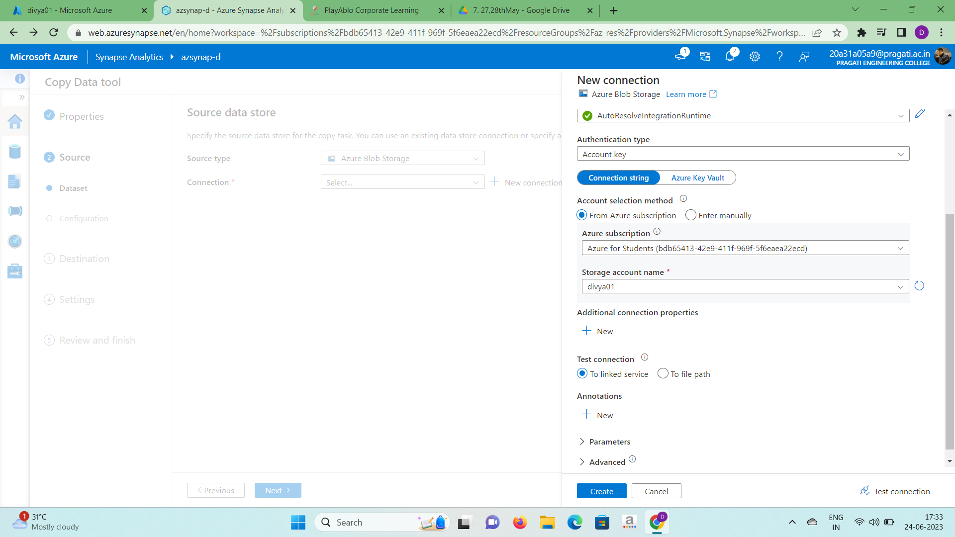

4.In the file or folder section click on browse and load all the parquet files and click on ok. In the options section select recursively and click on next.

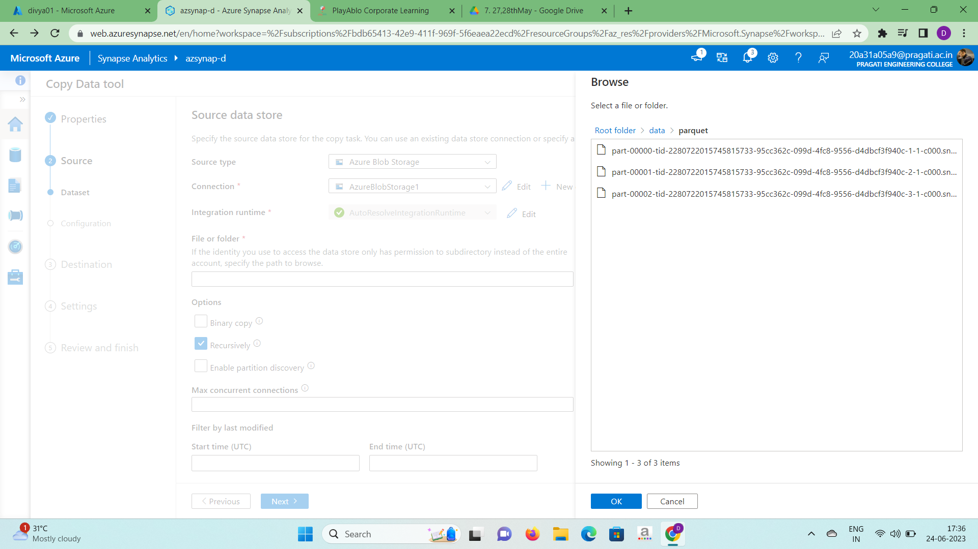

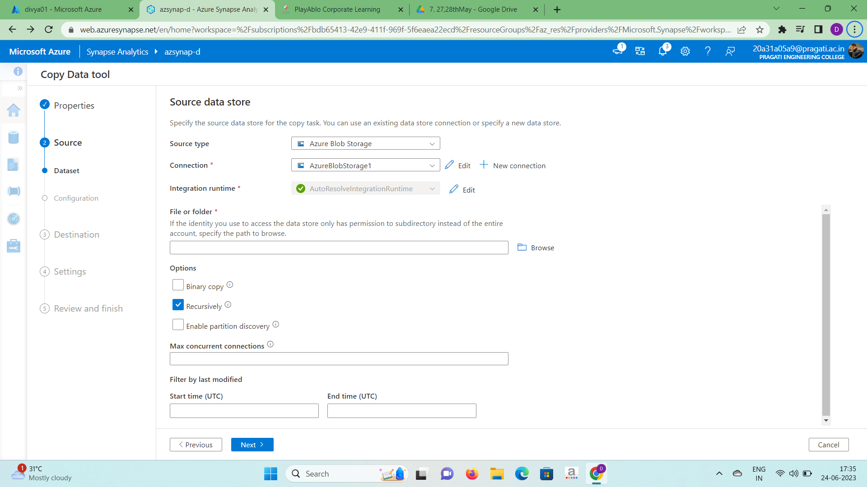

5.In the file format settings select the file format as parquet and you can also

preview your data by clicking on preview option and click on next.

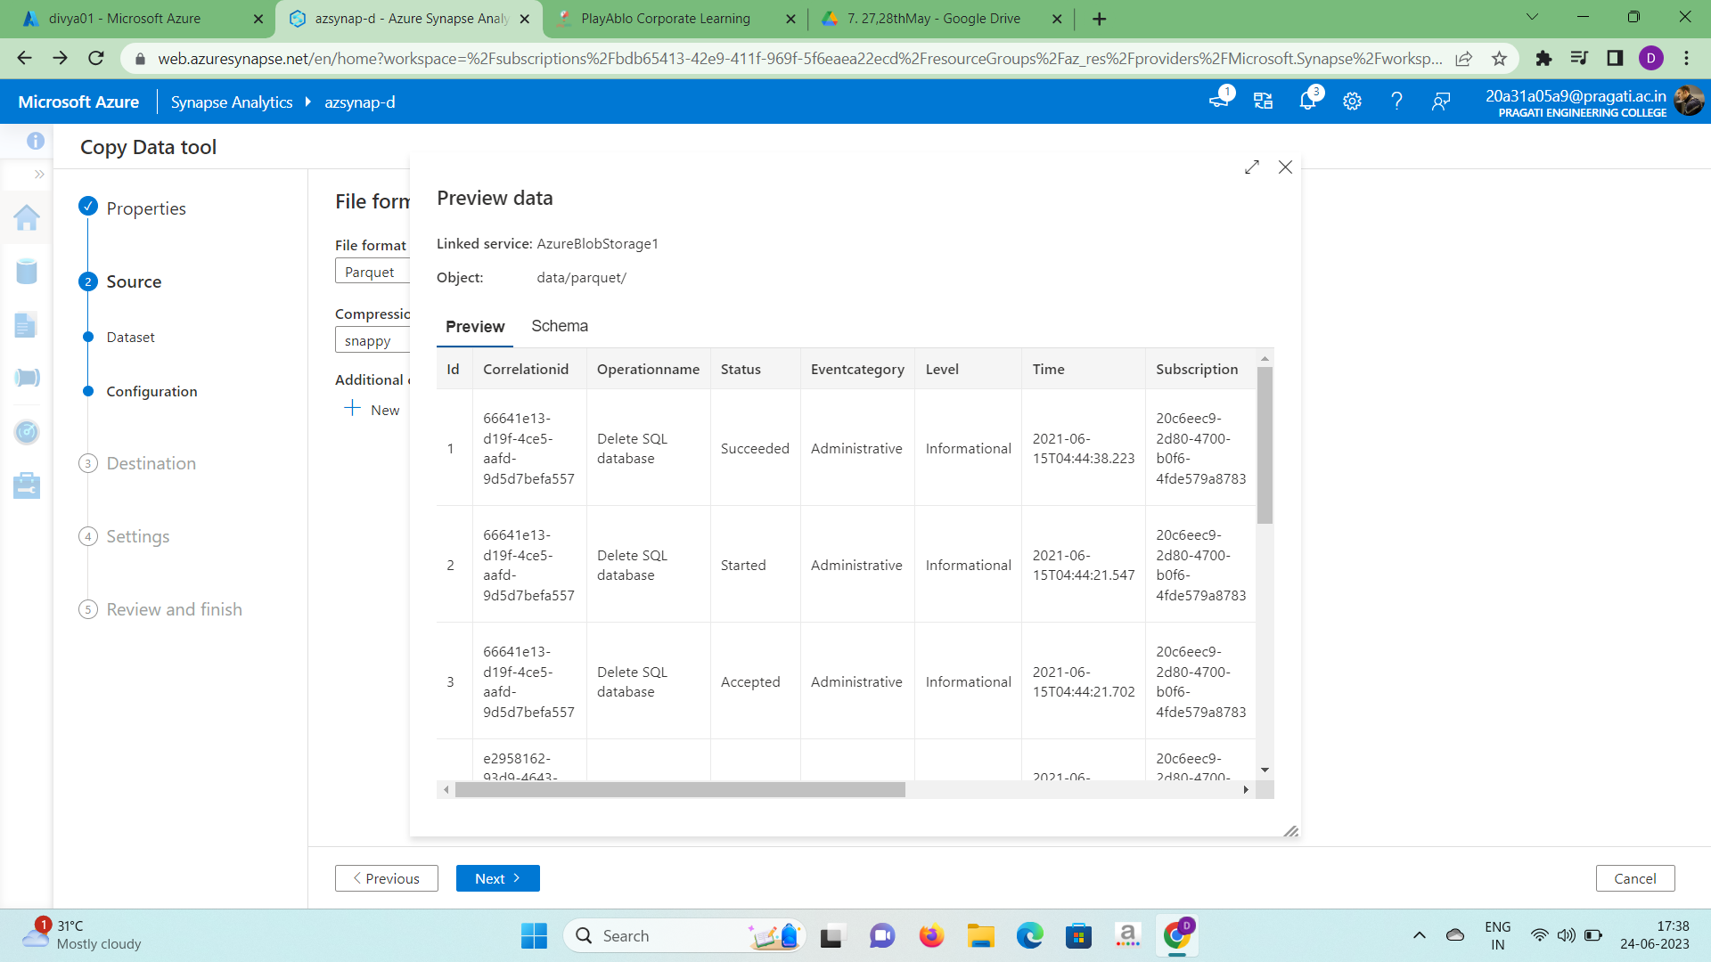

6.In the Destination data store window select the destination type as Azure Synapse Analytics and click on new connection.

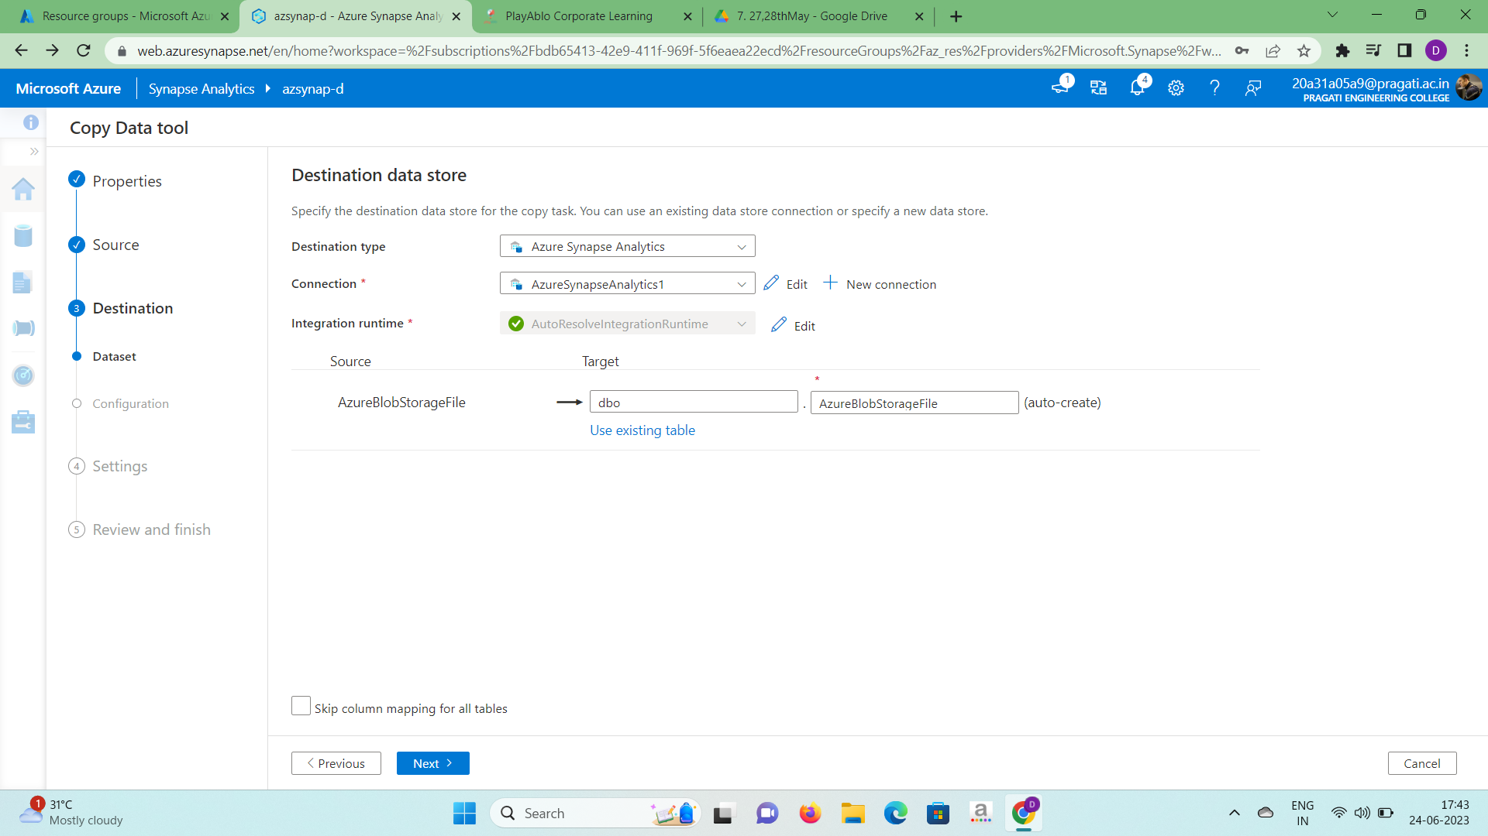

7.In the new connection portal.

* Select your azure subscription, sever name, database name and

authentication type as sql authentication.

* Username and password are to be mentioned, which you have created while creating the resources.
* Click on test connection. If the connection is successful click on create.

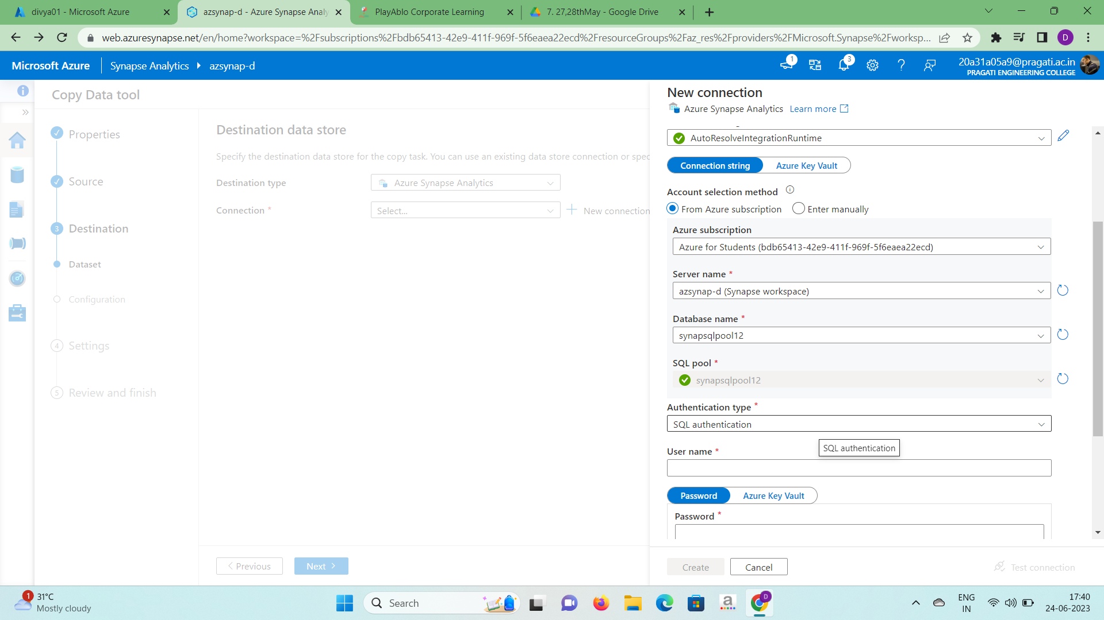

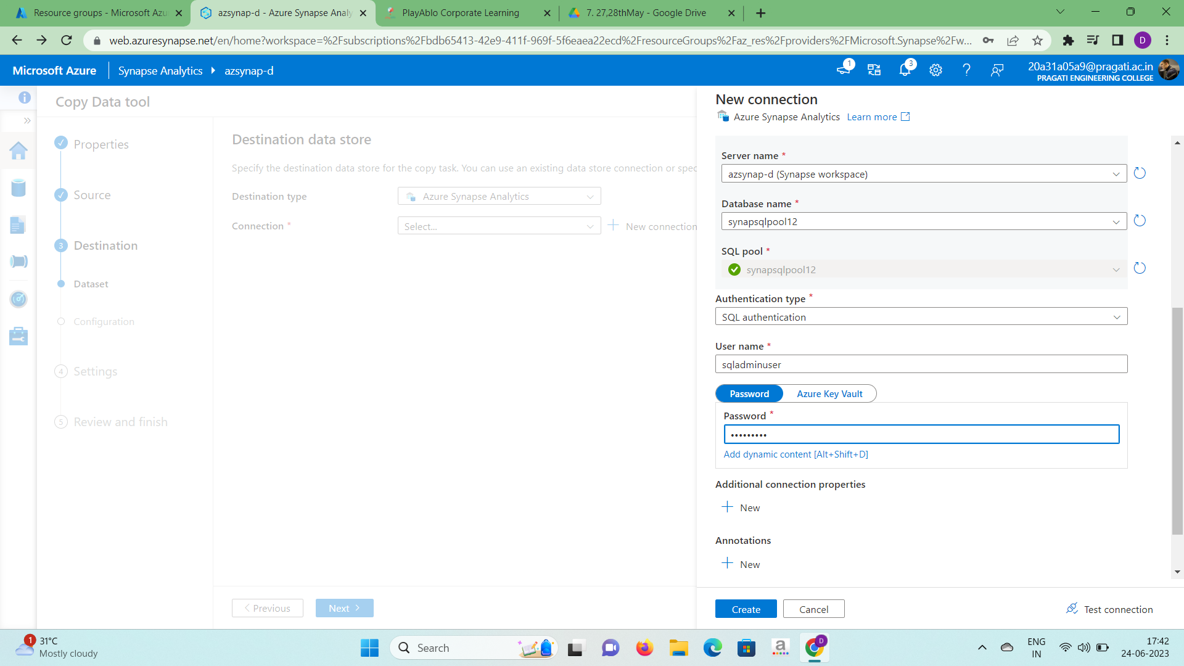

8.In the Azure Blob Storage File click on “use existing table” and select “dbo.logdata” and click on next.

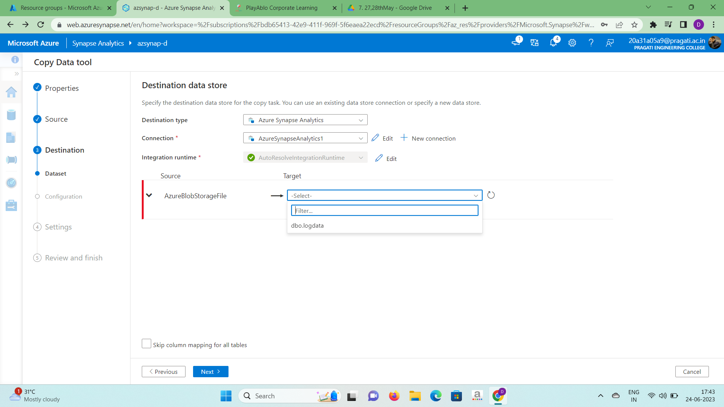

9.In the column mapping section it will automatically map the column names

between the source and destination as shown below. Click on next.

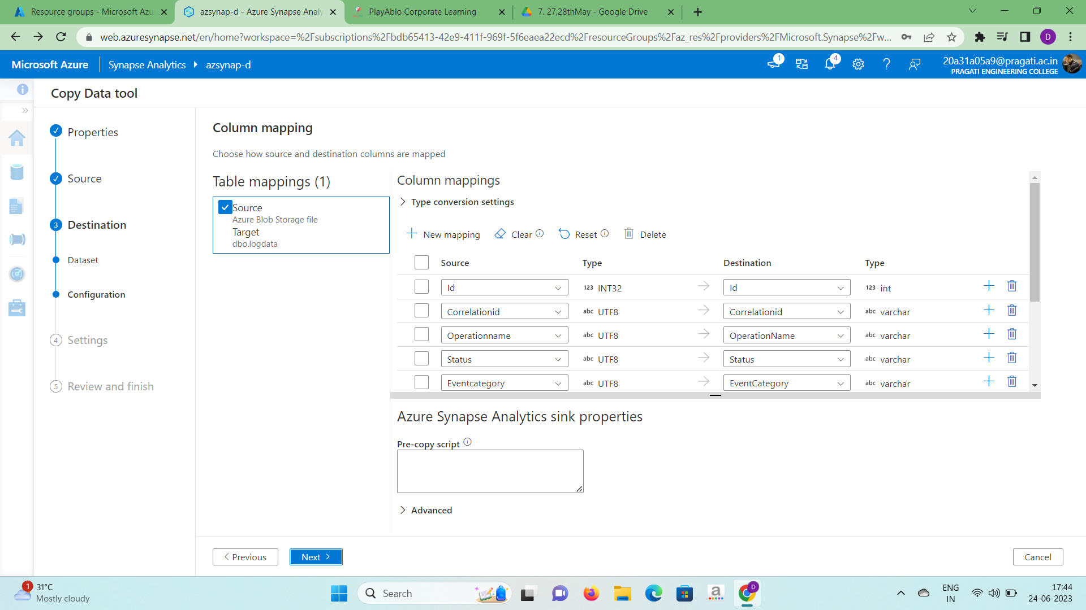

10.In the settings section

* Select “enable staging” option. We need staging area in order to keep our

data temporarily.

* Click on plus symbol beside the Staging account linked service in order to

create a new staging service.

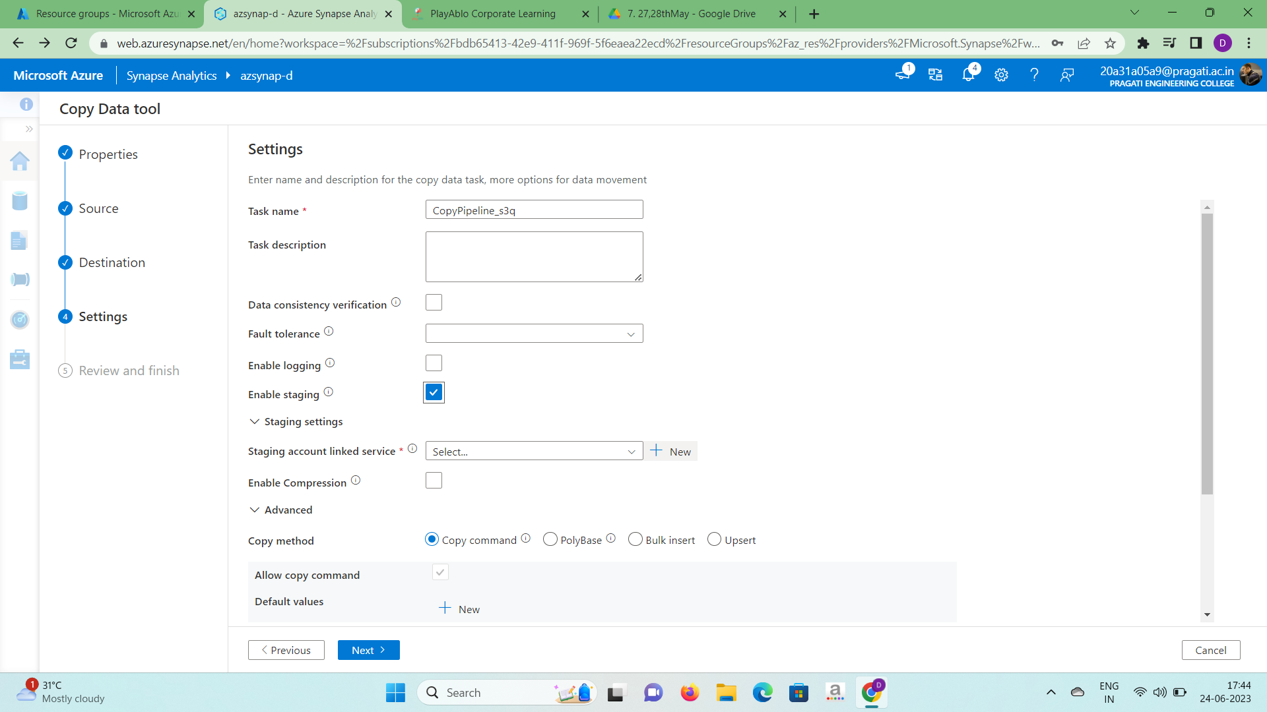

11.In the new linked service section.

* Select the azure subscription and storage account name which you have

created while creating a synapse account.

* Test the connection. If the connection is successful click on create.

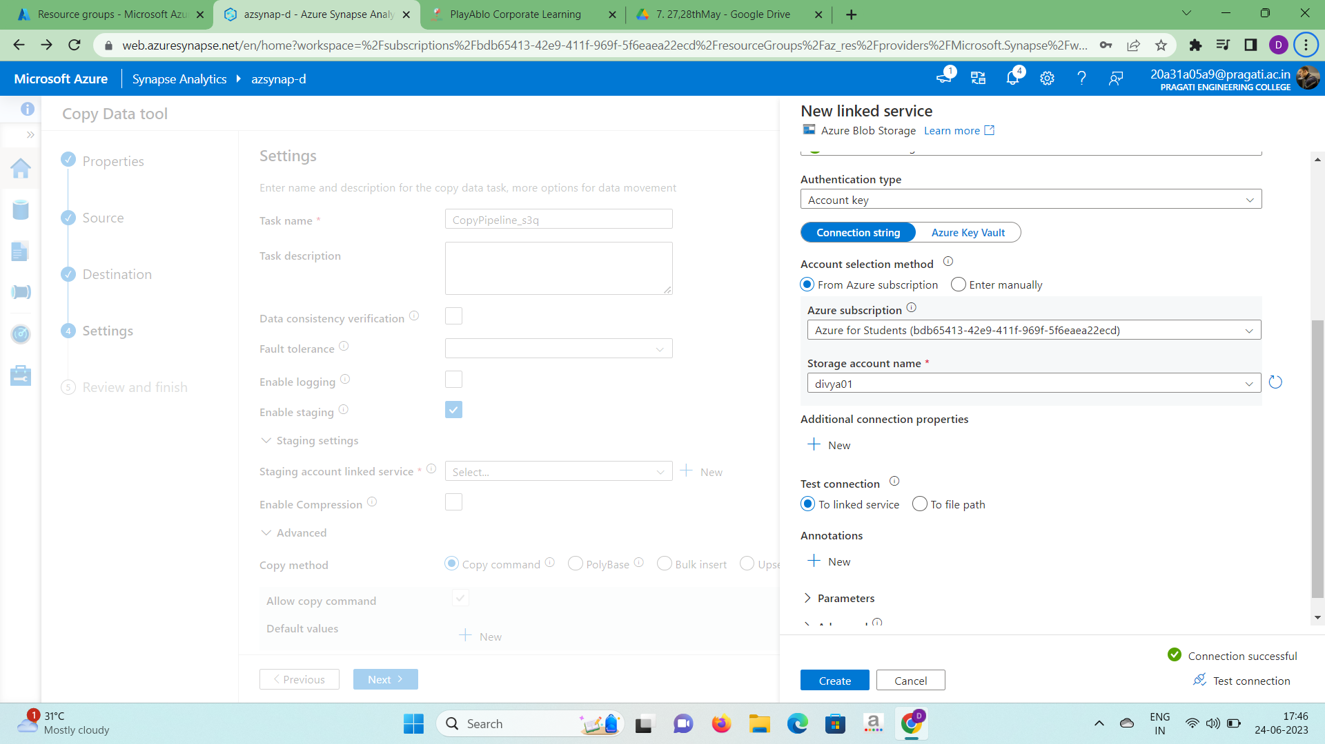

12.Click on browse of the storage path and select the folder. Select “bulk insert”

option in the copy method column and click on next.

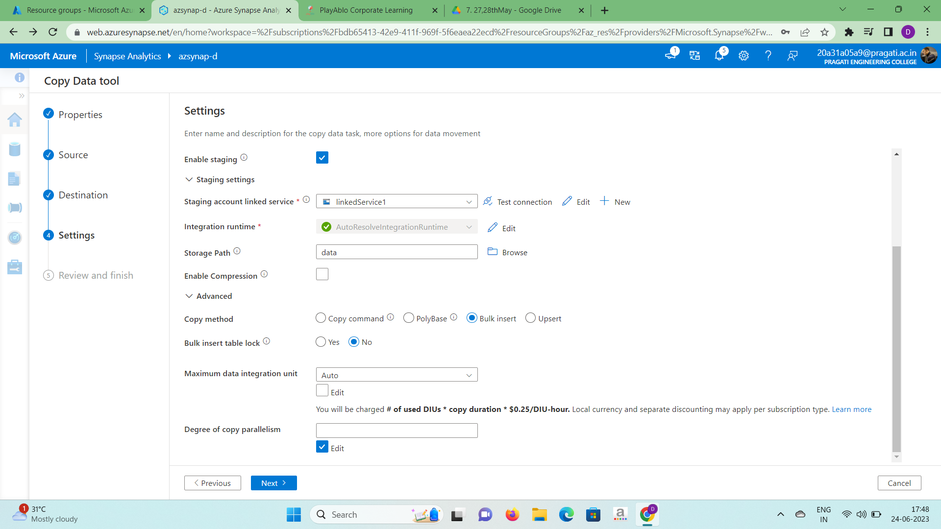

13.Deployment will be completed after few minutes and click on finish.

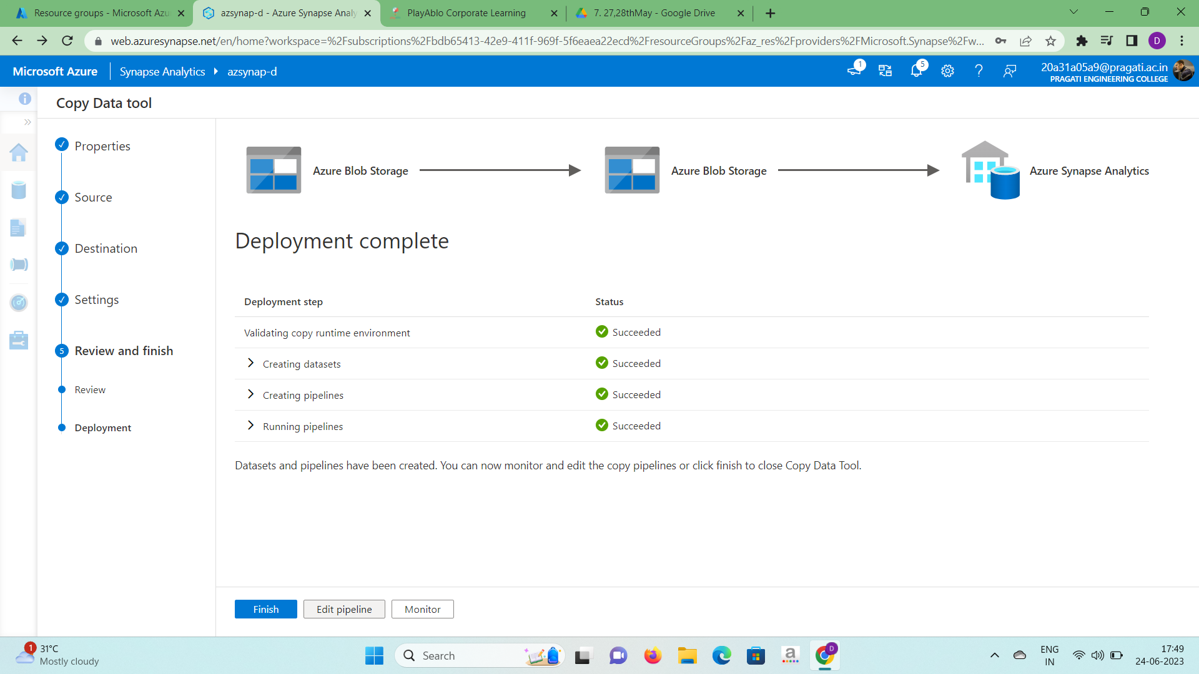

14.Goto monitor section and click on pipeline runs you will find the pipeline which you have created over there.

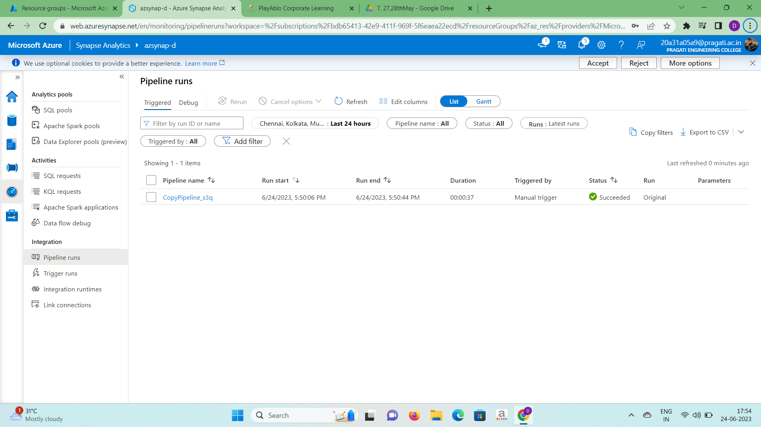

15.Pipeline has been created.